
NABWIGULU SEED SECONDARY SCHOOL
P.O BOX 171, KAMULI
Email: nabwiguluseedsecondaryschool@gmail.com
Tel: 0705884458 / 0772894458
Motto: ‘‘Mukama Tagabira Batudde”
SCHOOOL ASSETS
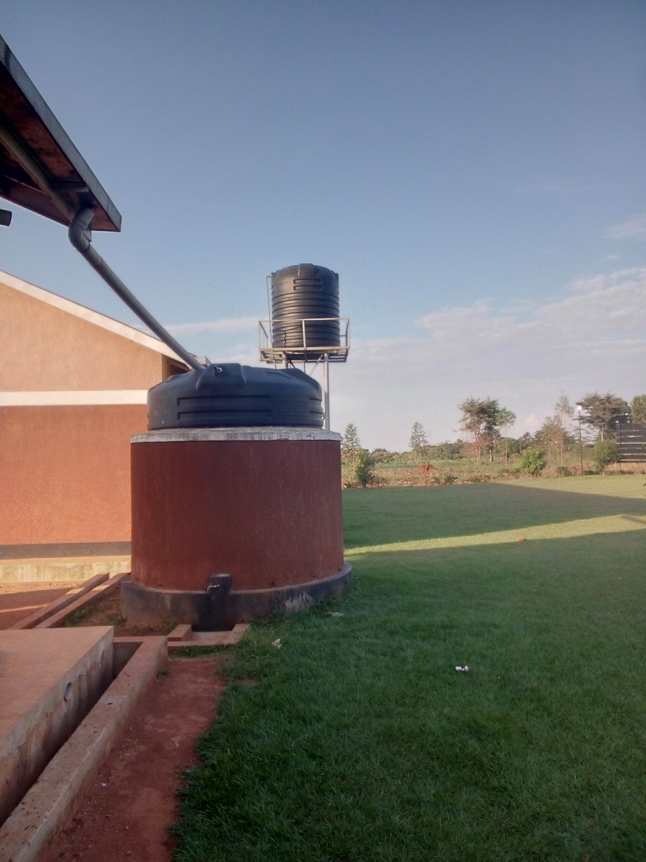O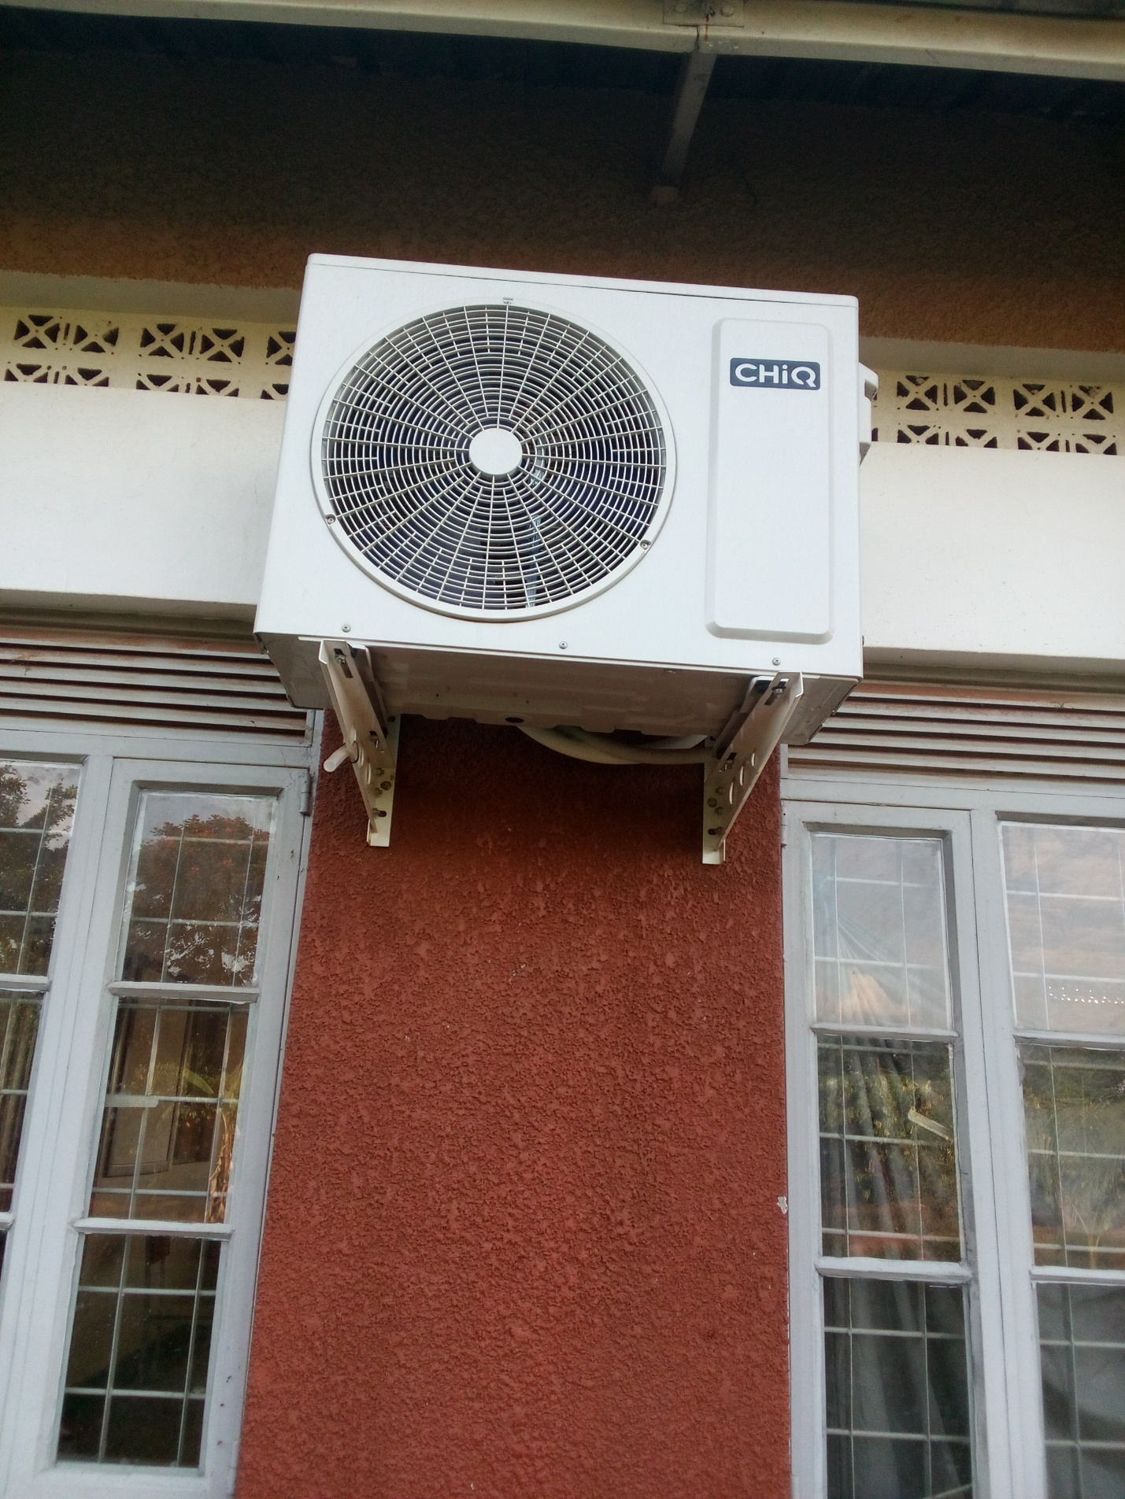
WATER SYSTEM FOR THE LABORATORY
CONDENSER OF A SPLIT AIR CONDITIONER: OUTSIDE UNIT

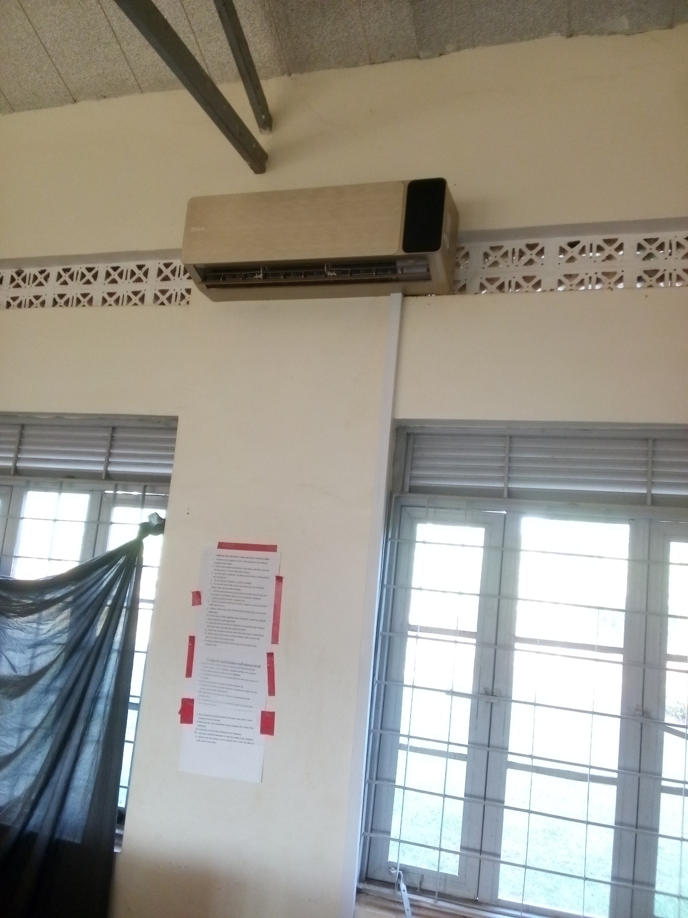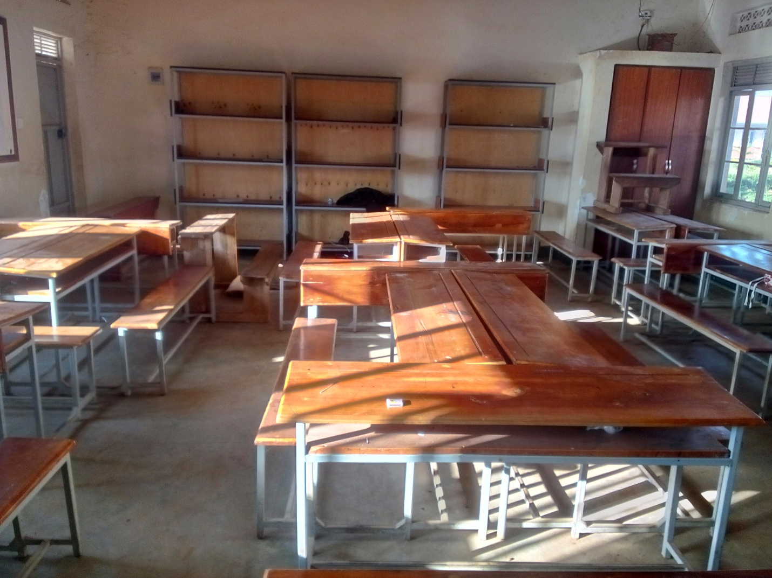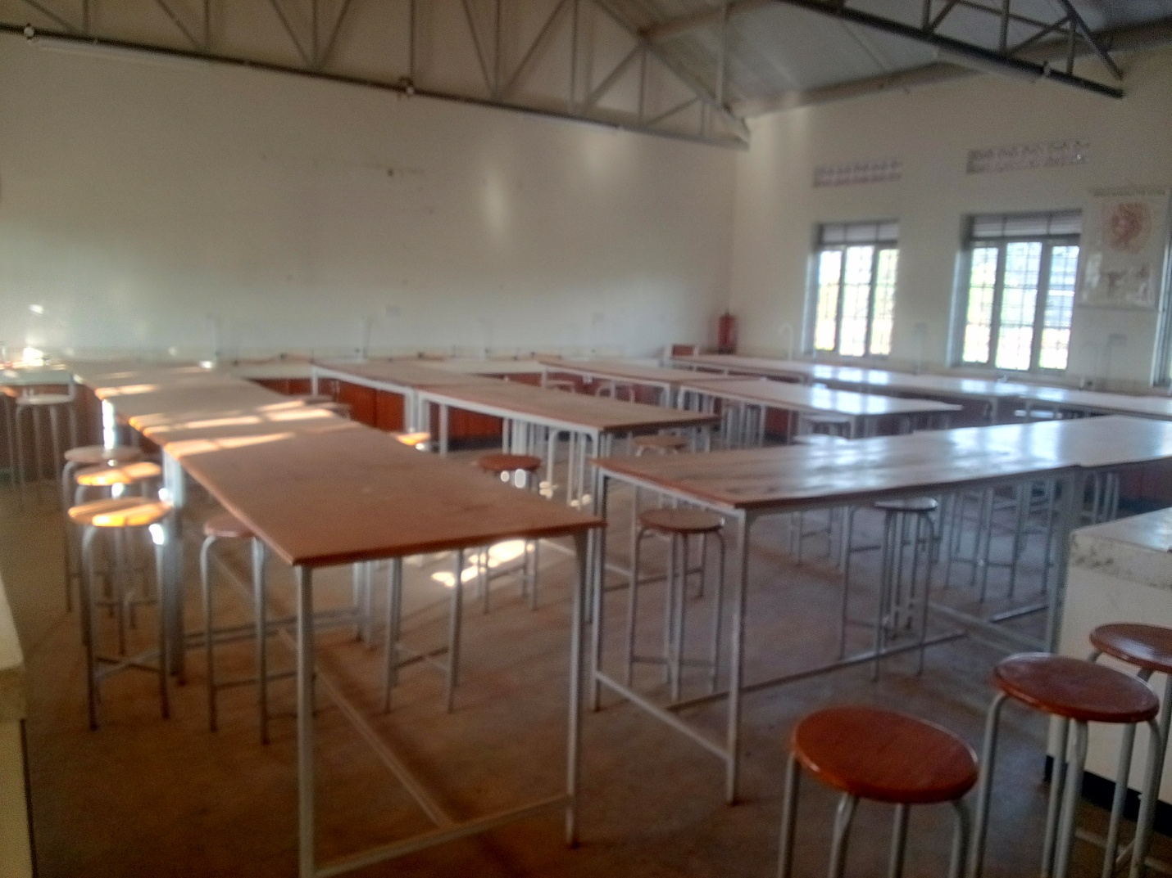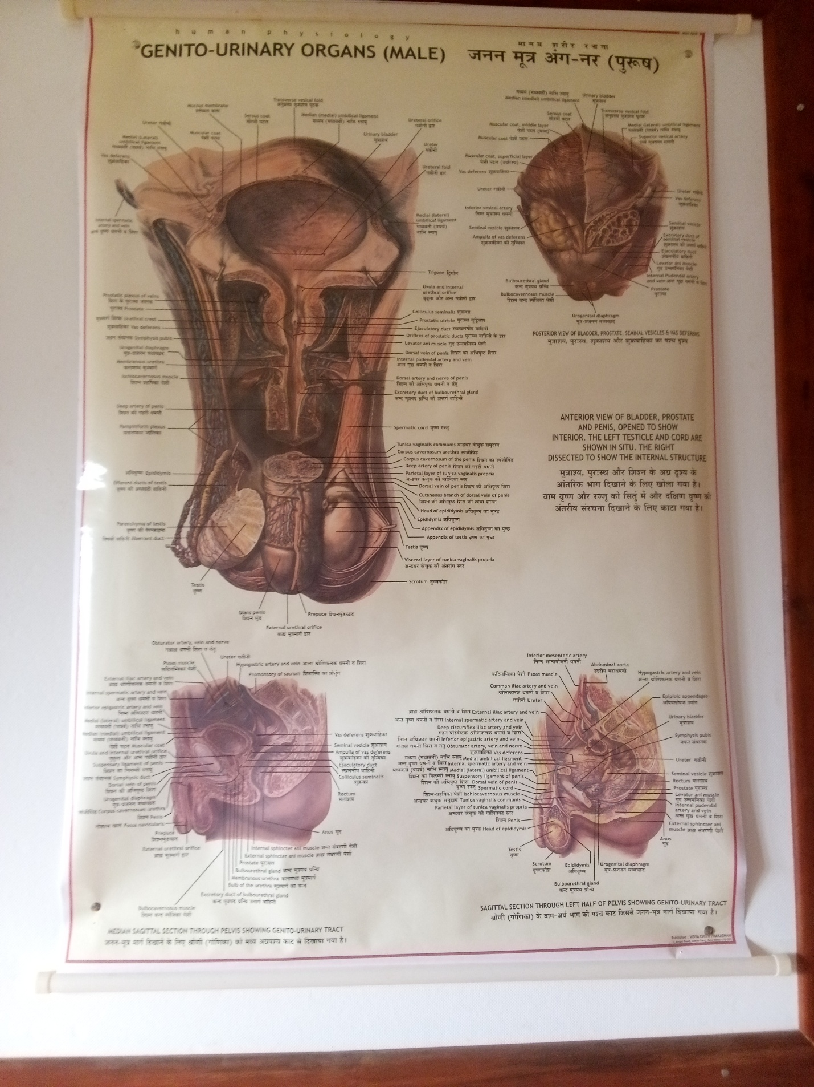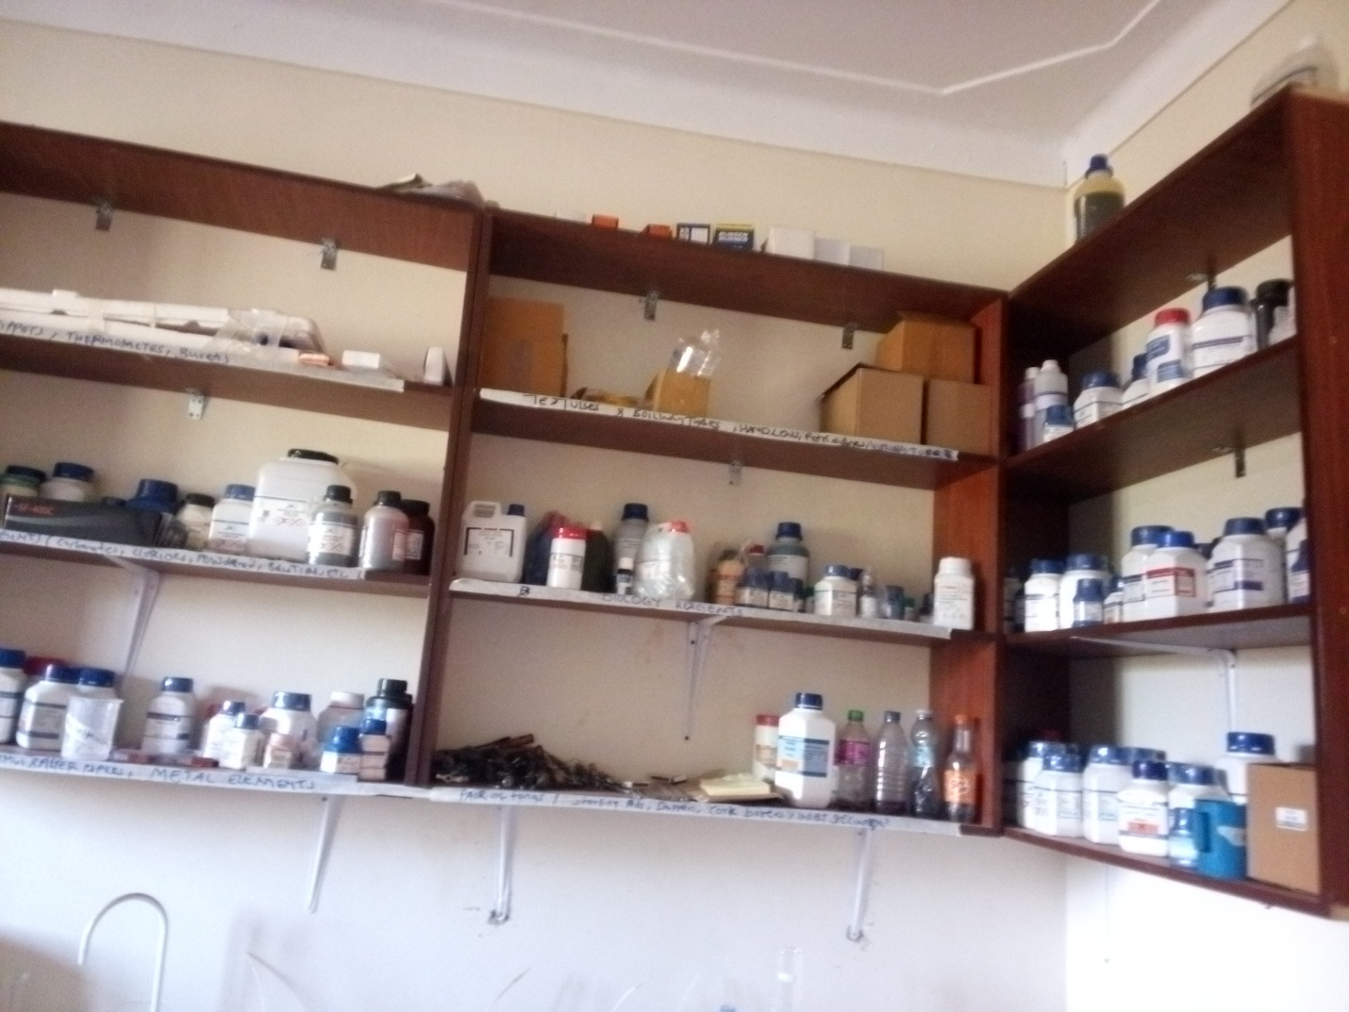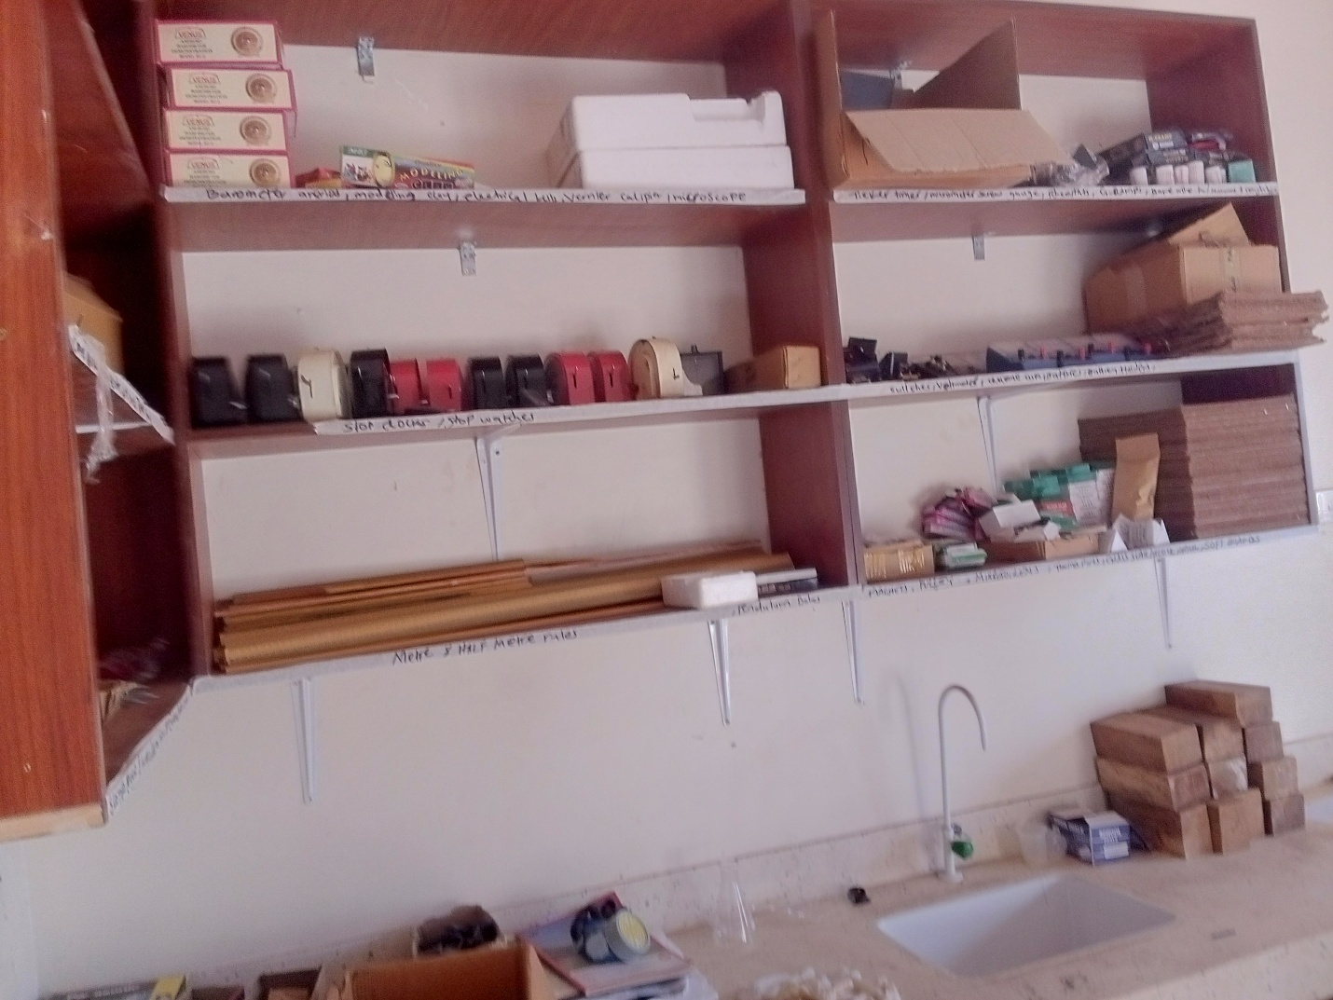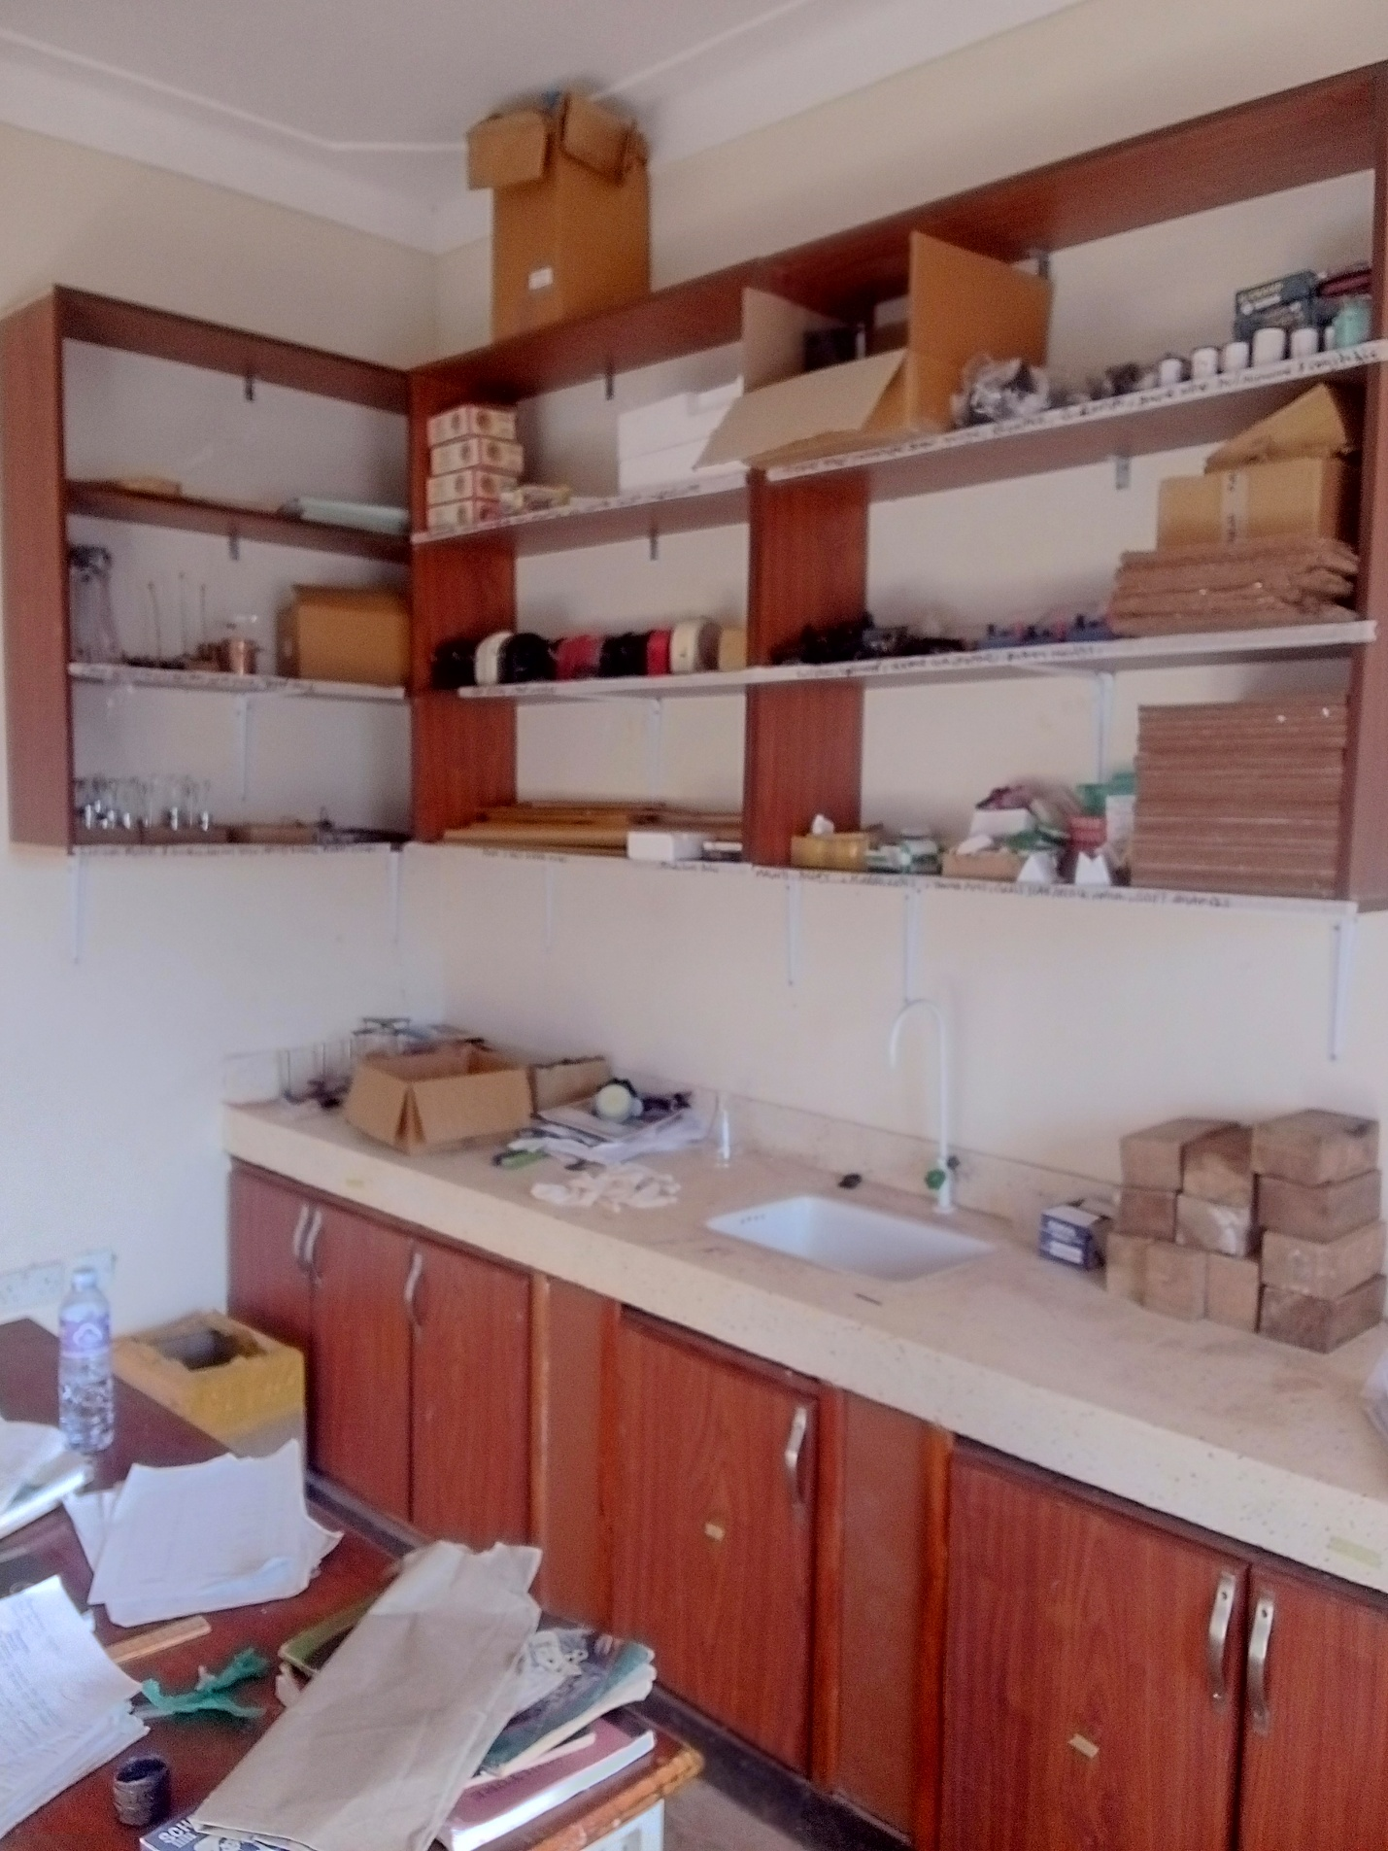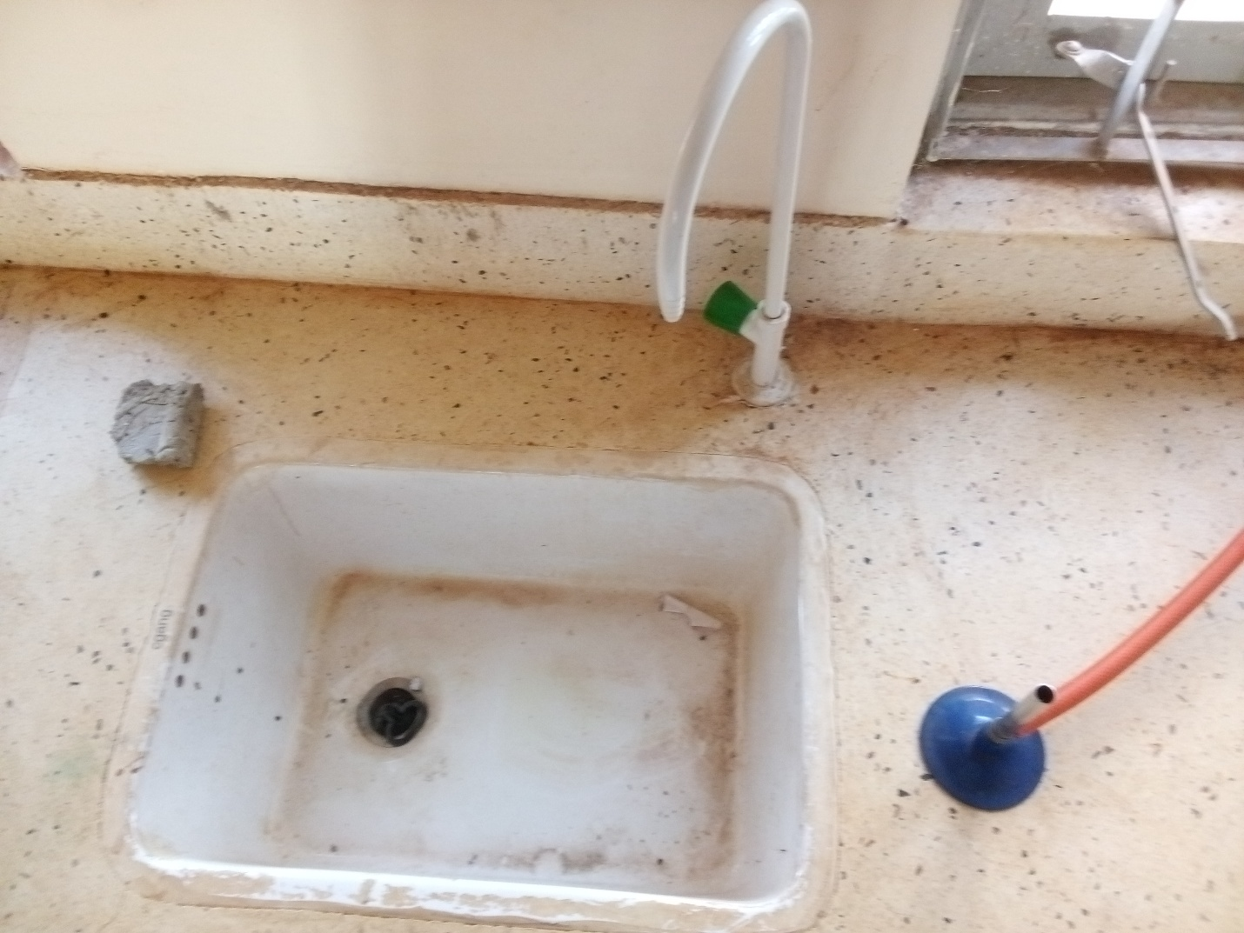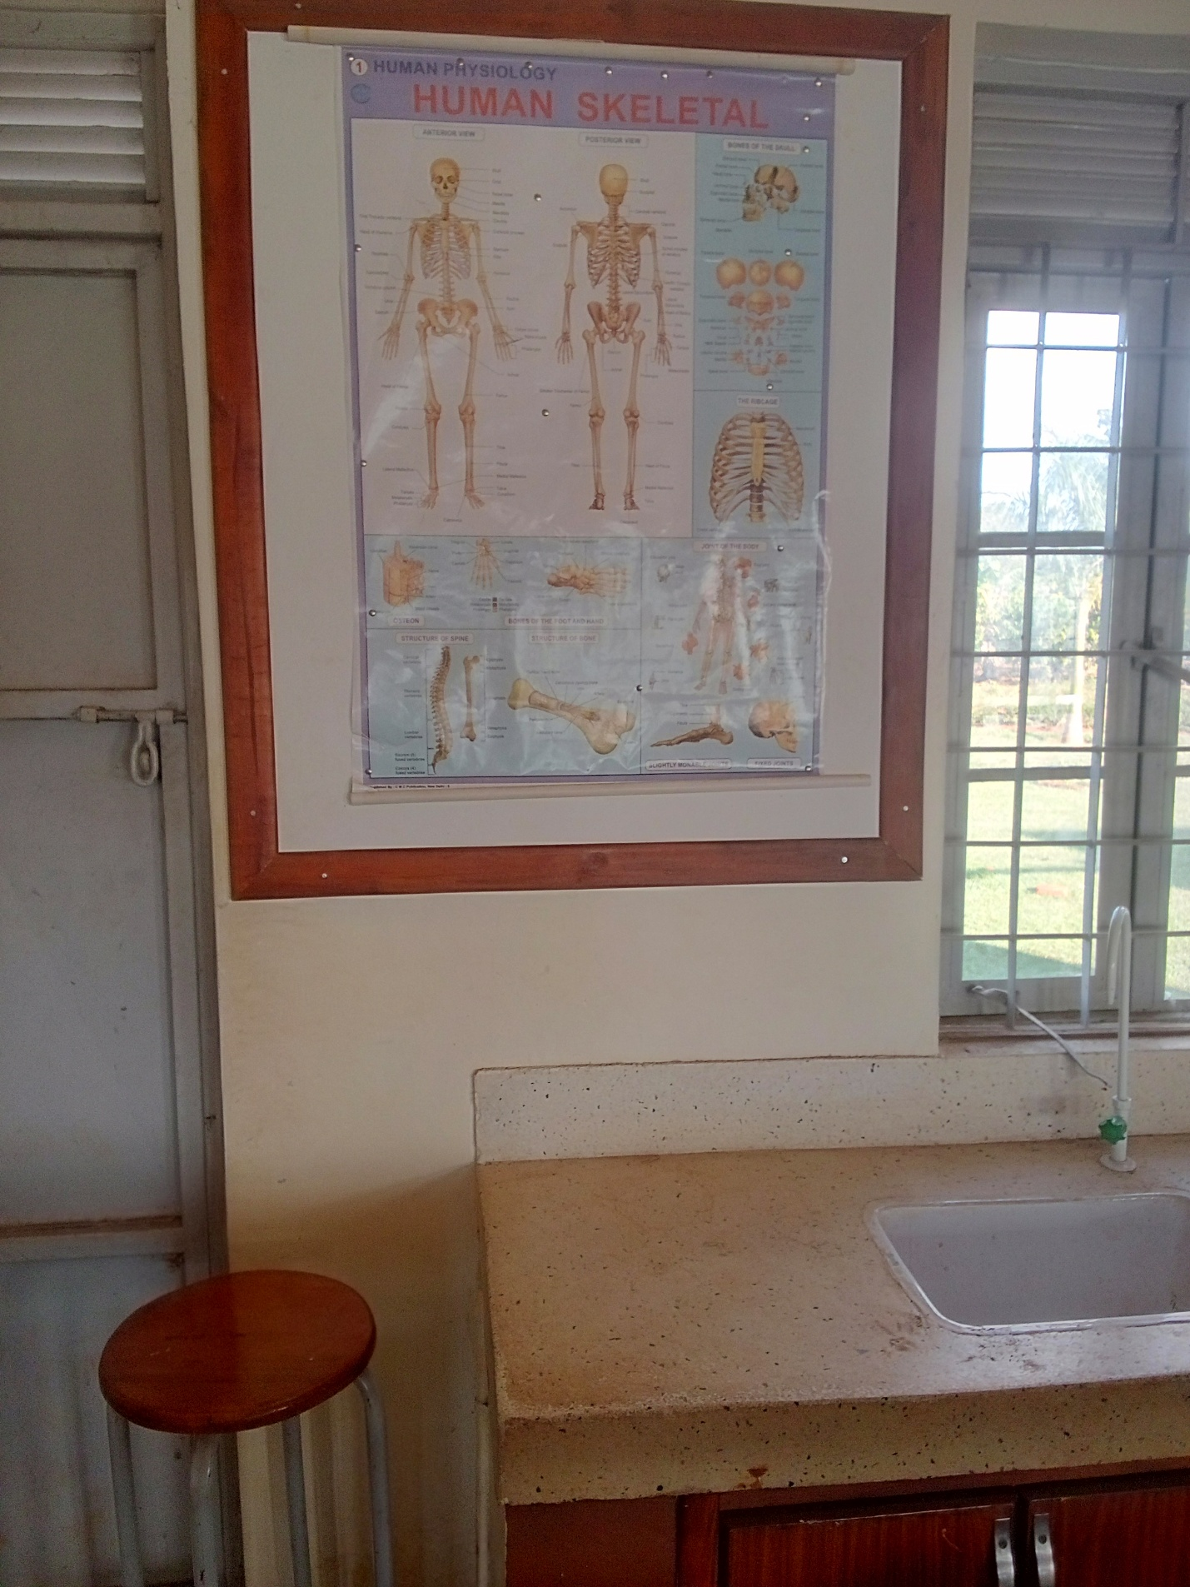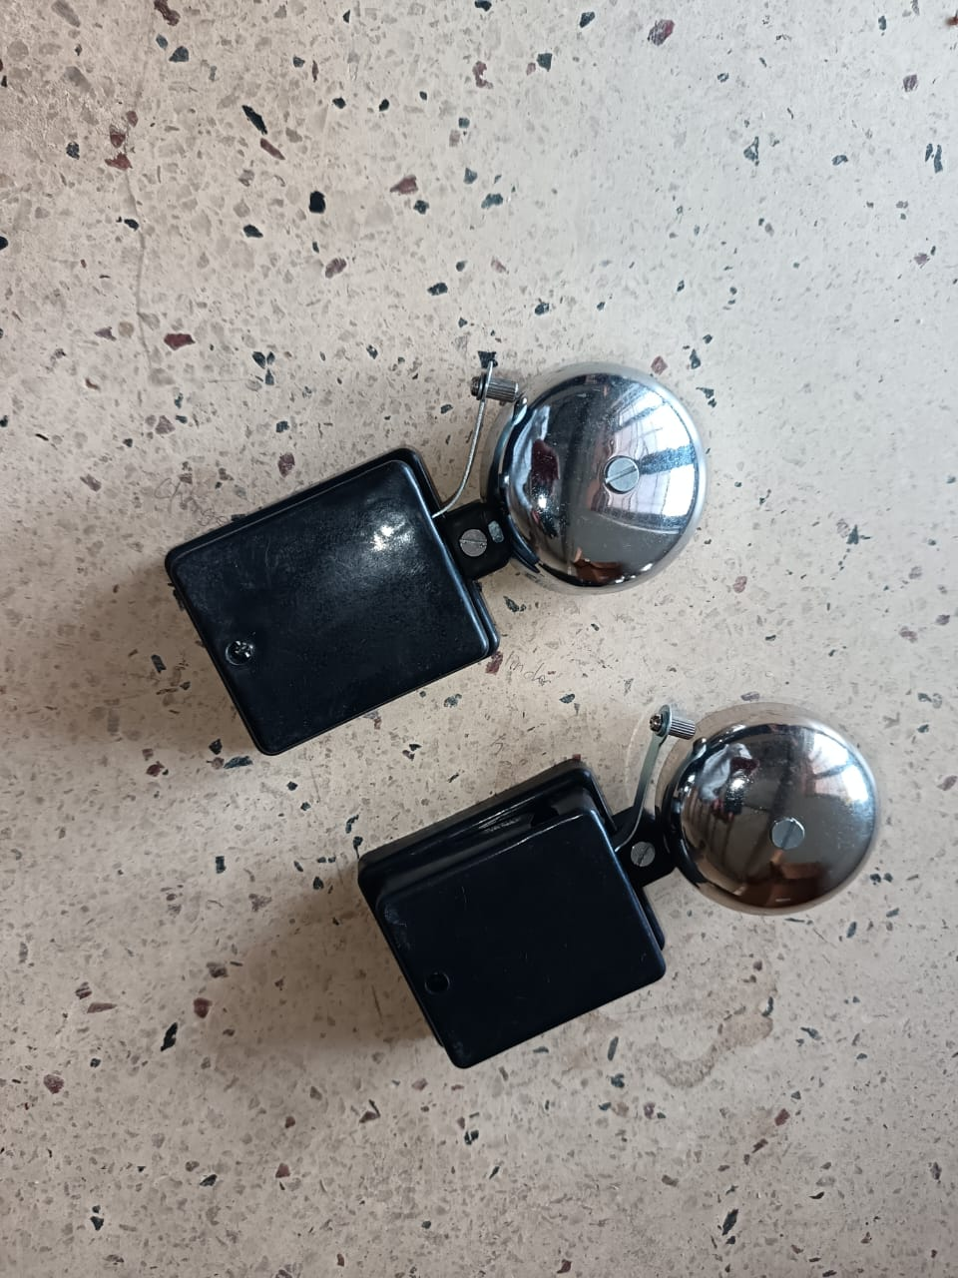
AIR CONDITIONER INSIDE
COMPUTER LABORATORY RULES DISPLAYED IN THE COMPUTER LABORATORY
CLASS ROOM
SCIENCE LABORATORY ROOM
BIOLOGY CHART
CHEMISTRY / BIOLOGY CHEMICALS
SCIENCE LABORATORY LOCKERS FOR CHEMICALS
SINK, WATER TAP AND BUSERN BURNER
SCIENCE CHART AND SINK IN THE LABORATORY
ELECTRIC BELLS
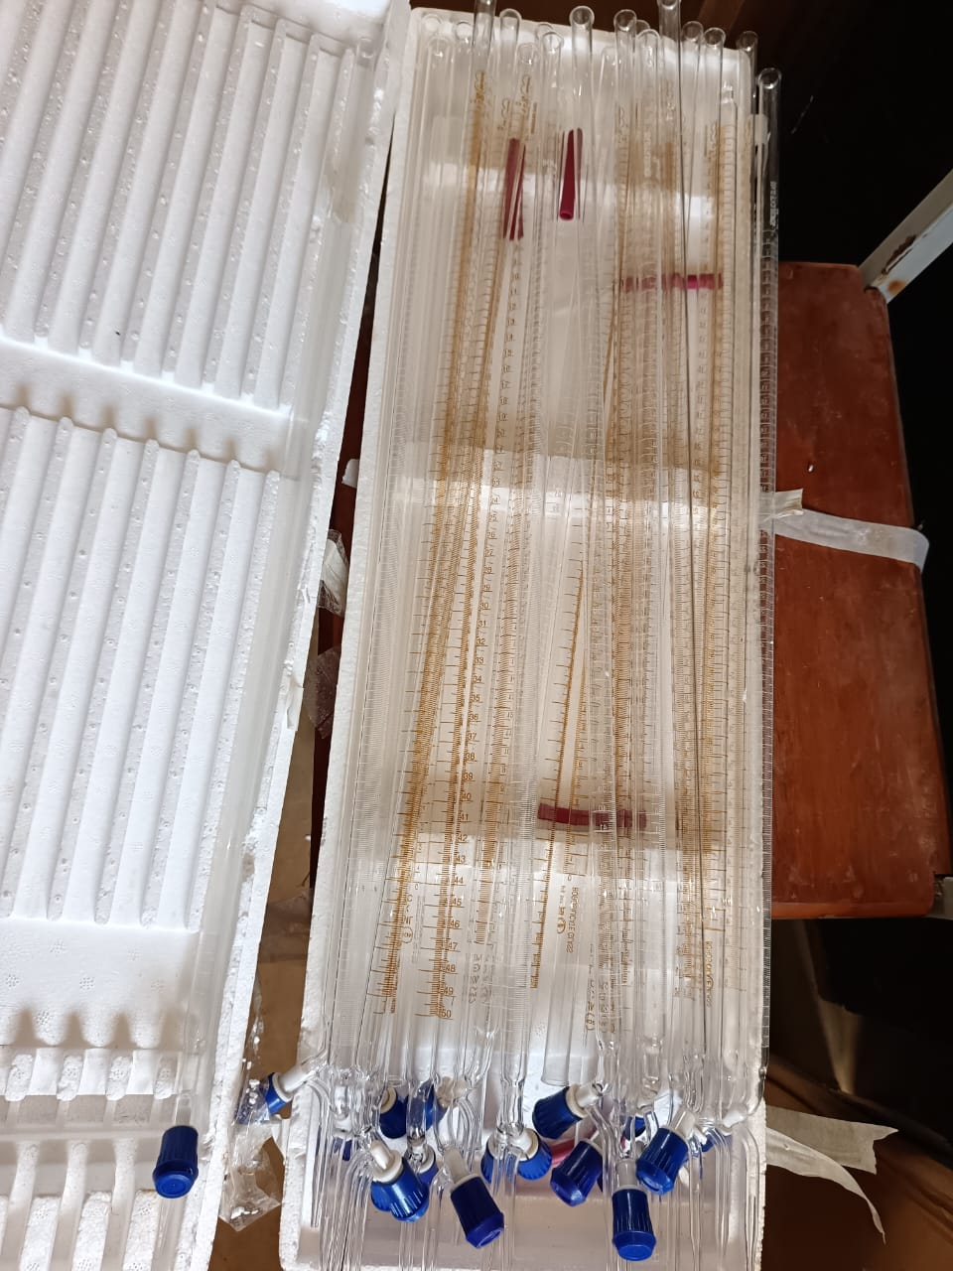
BURRETES
BURRETES
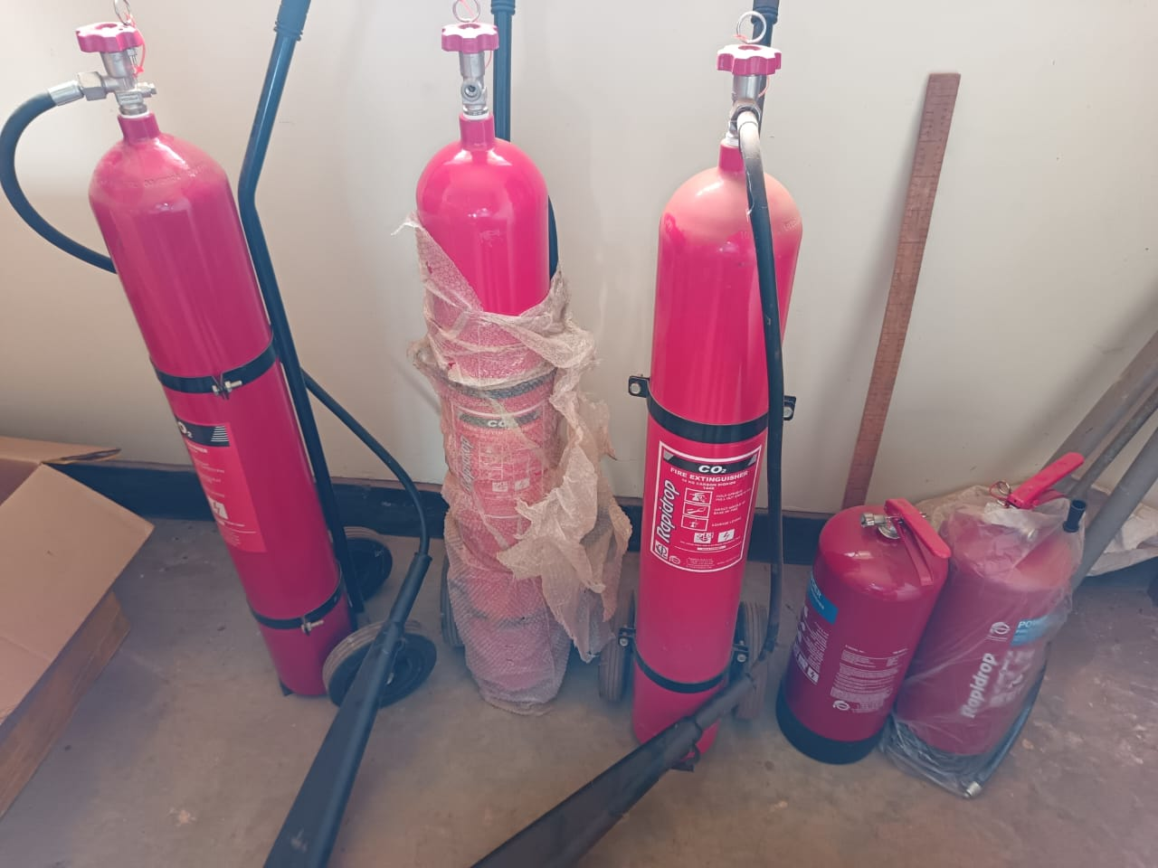
FIRE EXTINGUISHERS IN THE SCIENCE LABORATORY

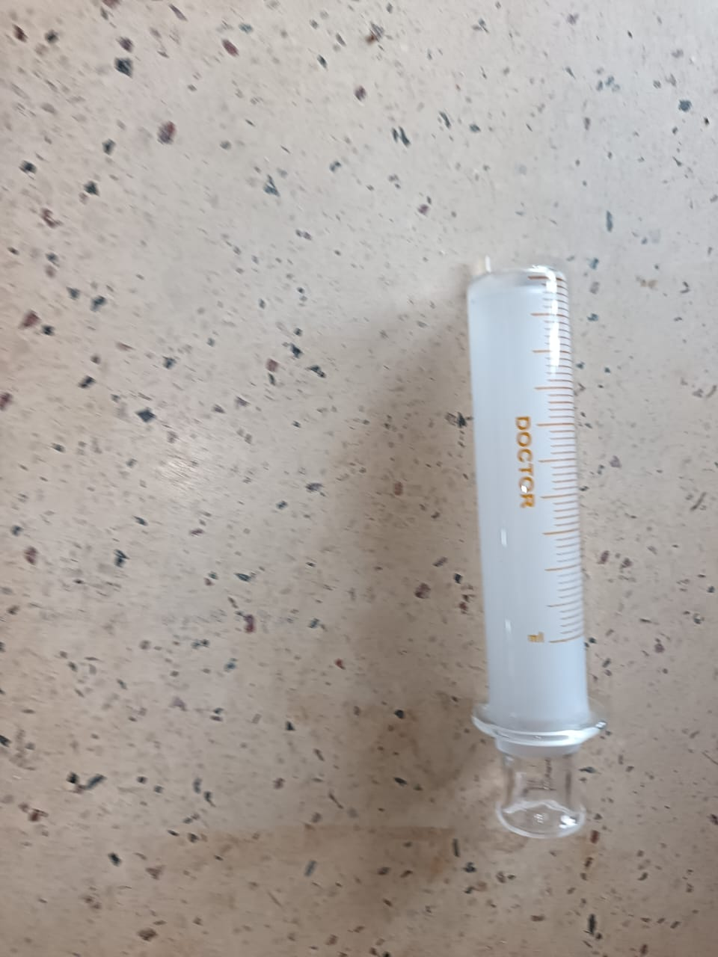
SYRINGE
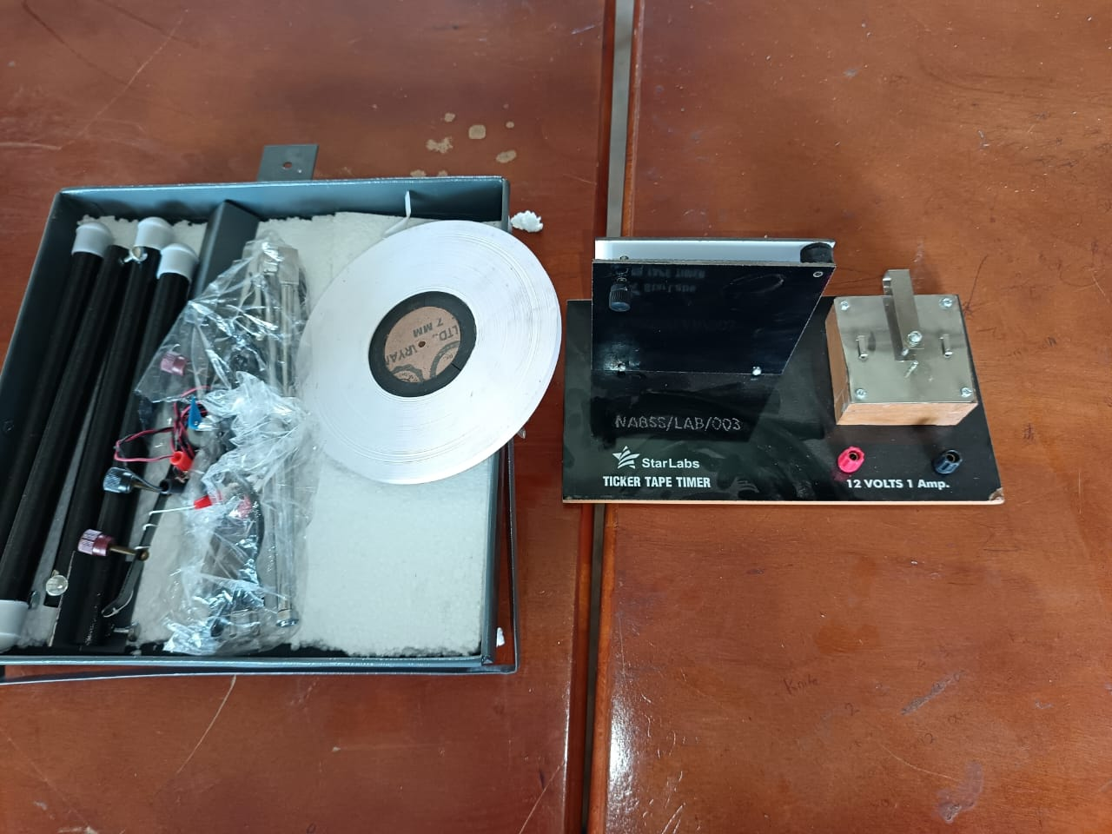
RINPLE TANK AND TICK TIMER
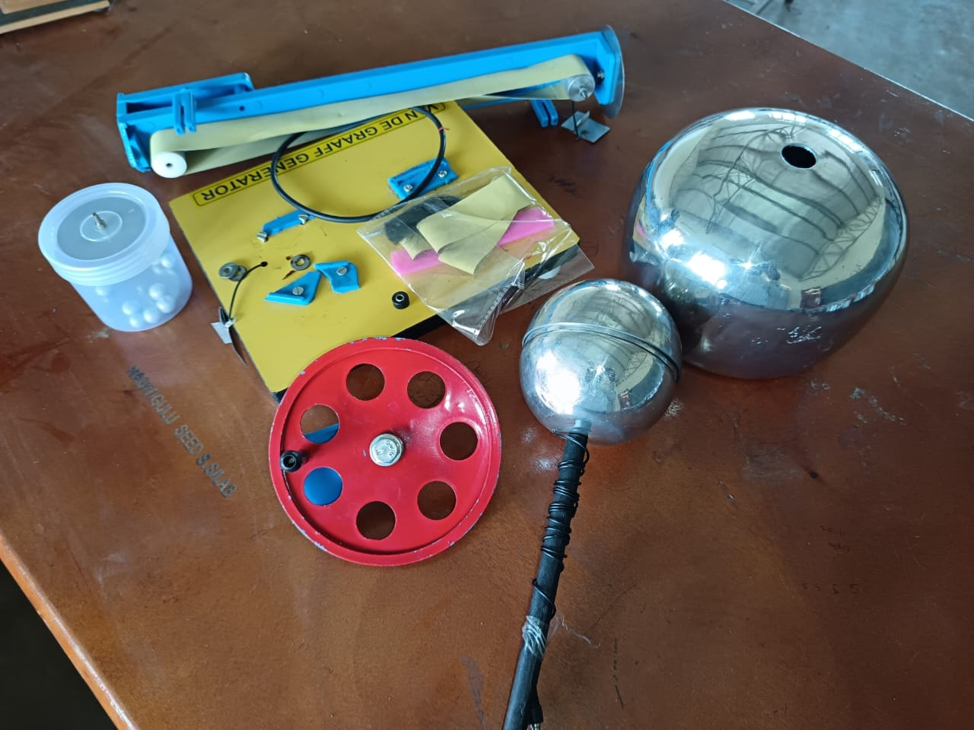
VAN DE GRAAFF GENERATOR
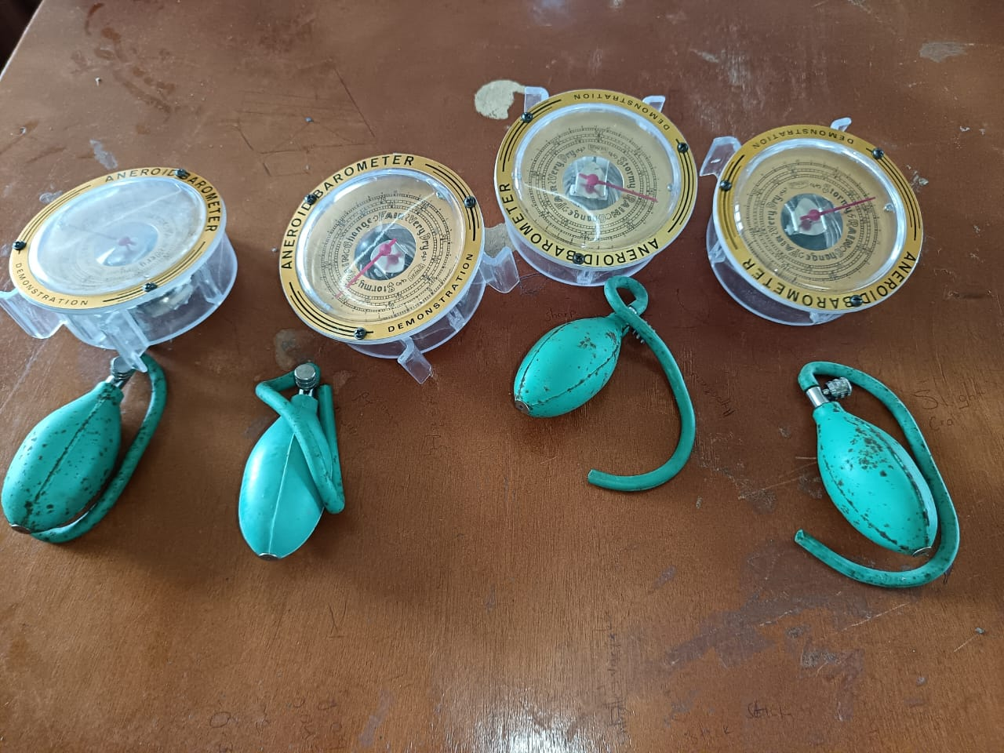
MANOMETERS
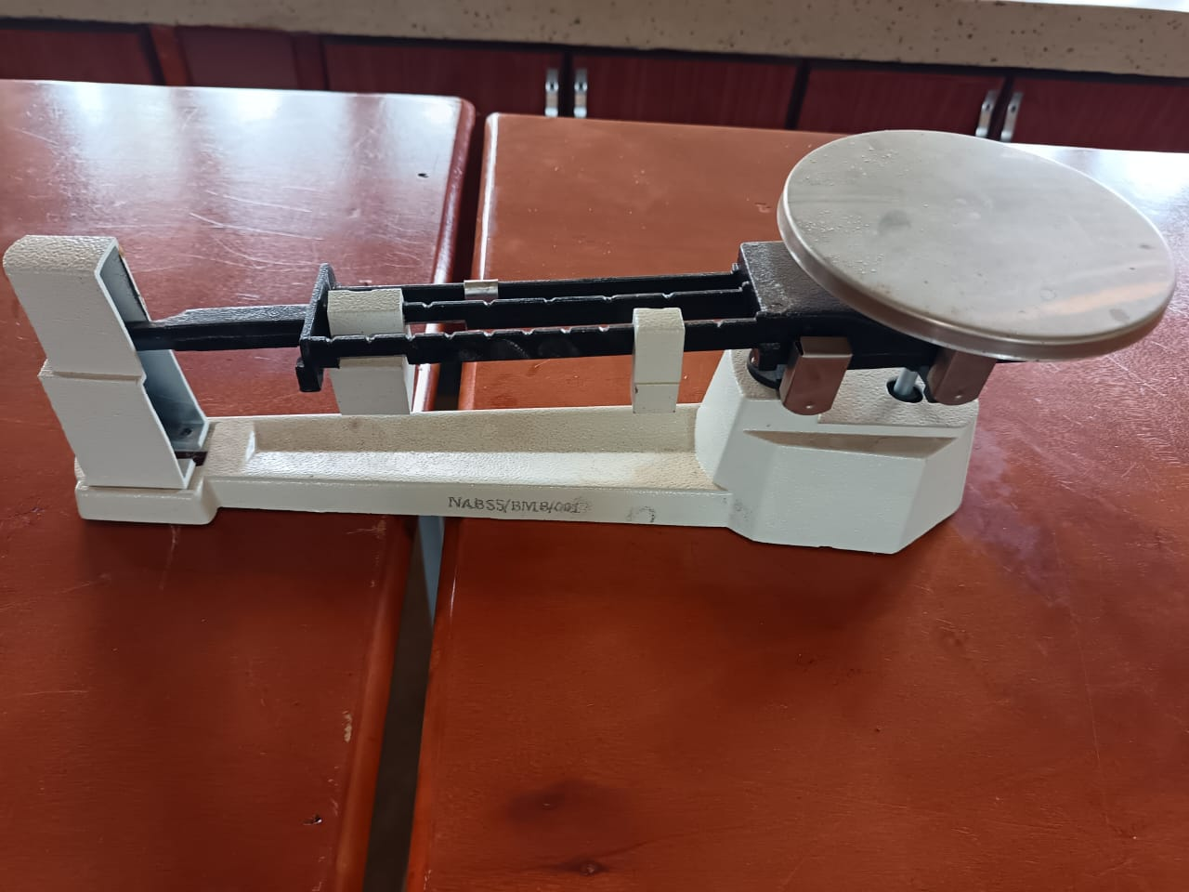
BEAM BALANCE

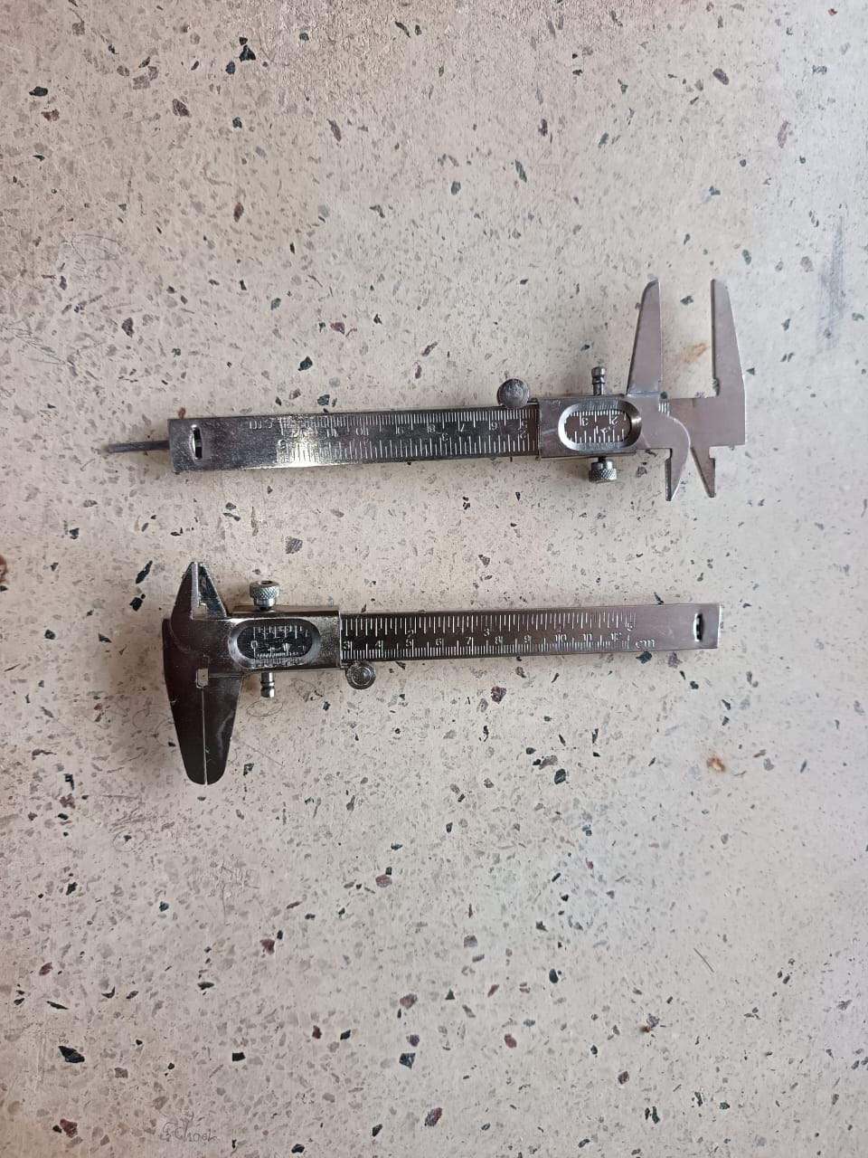
VANIER CALIPERS
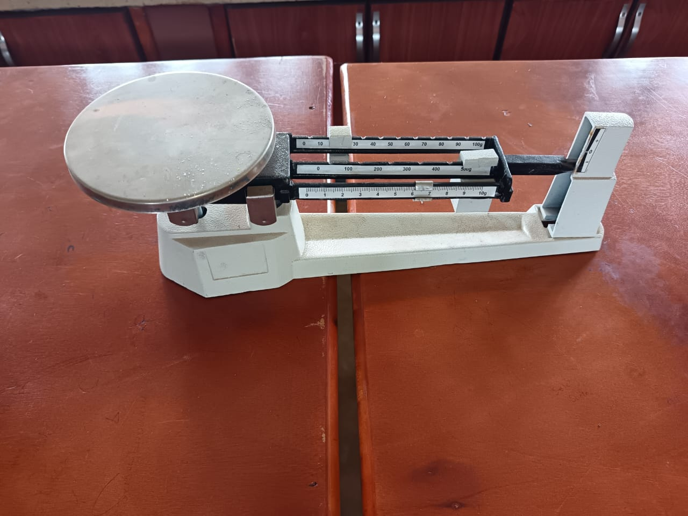
BEAM BALANCE
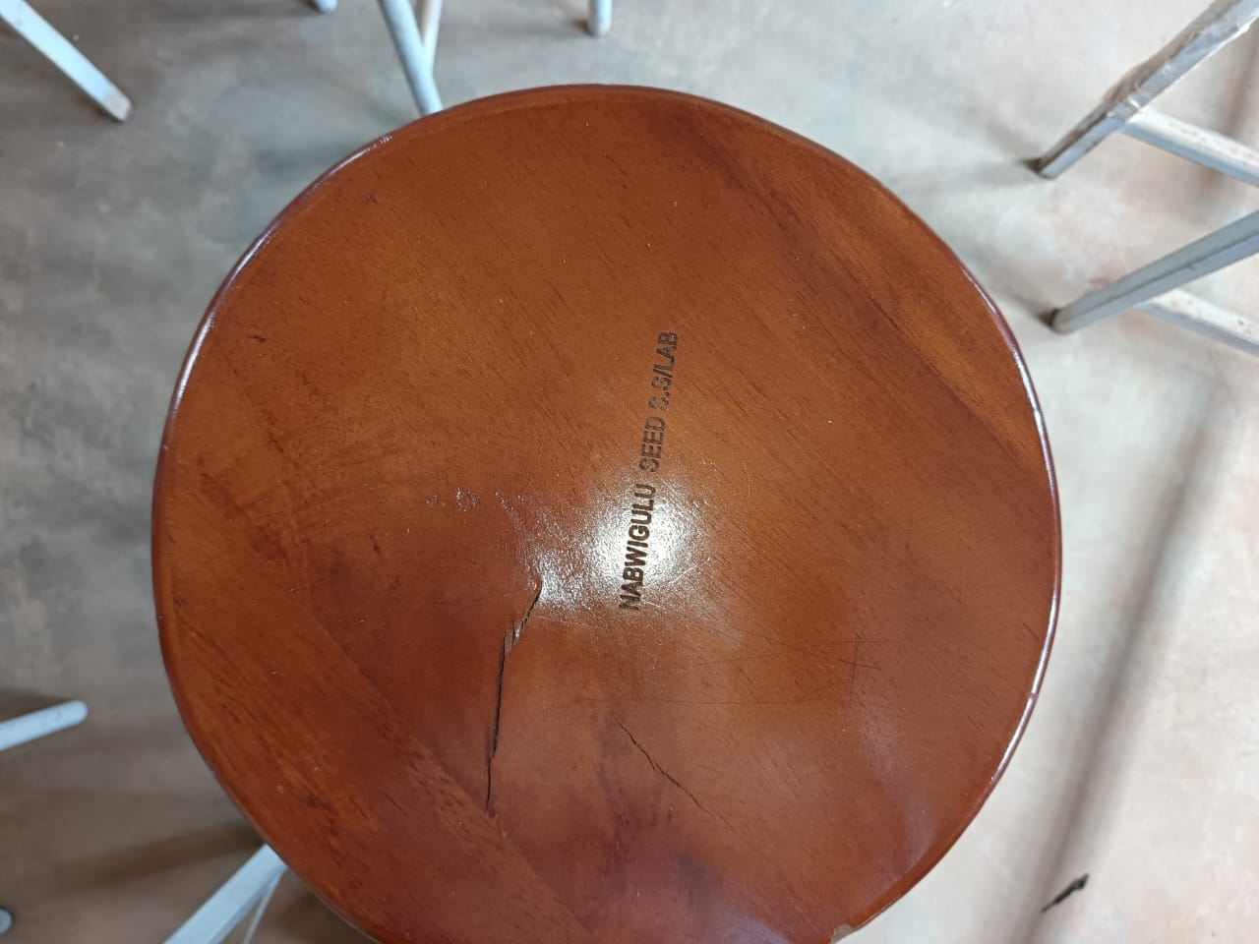
SCIENCE LABORATORY STOOL
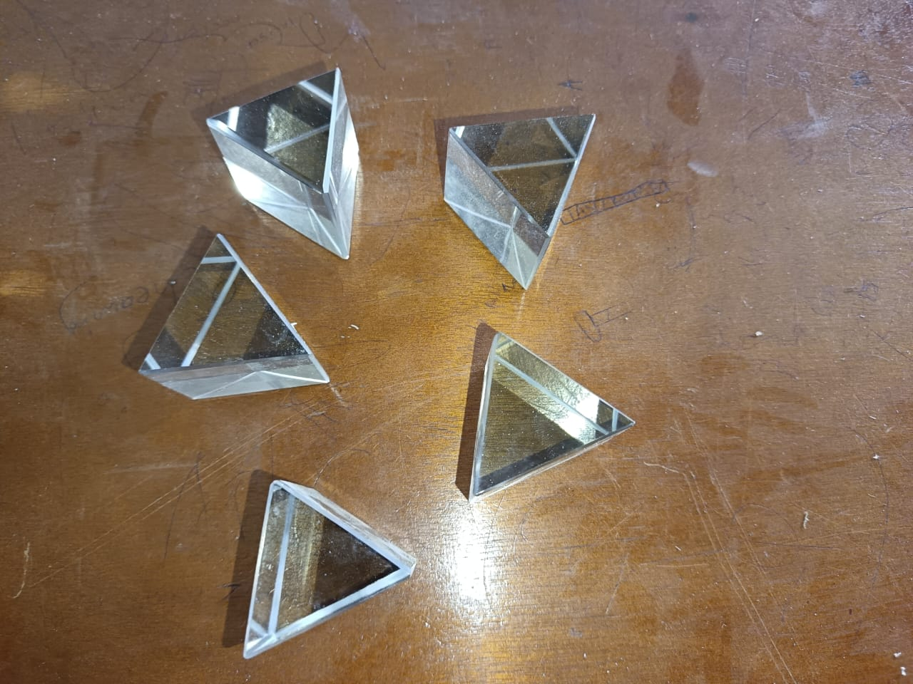
TRIANGULAR PRISMS
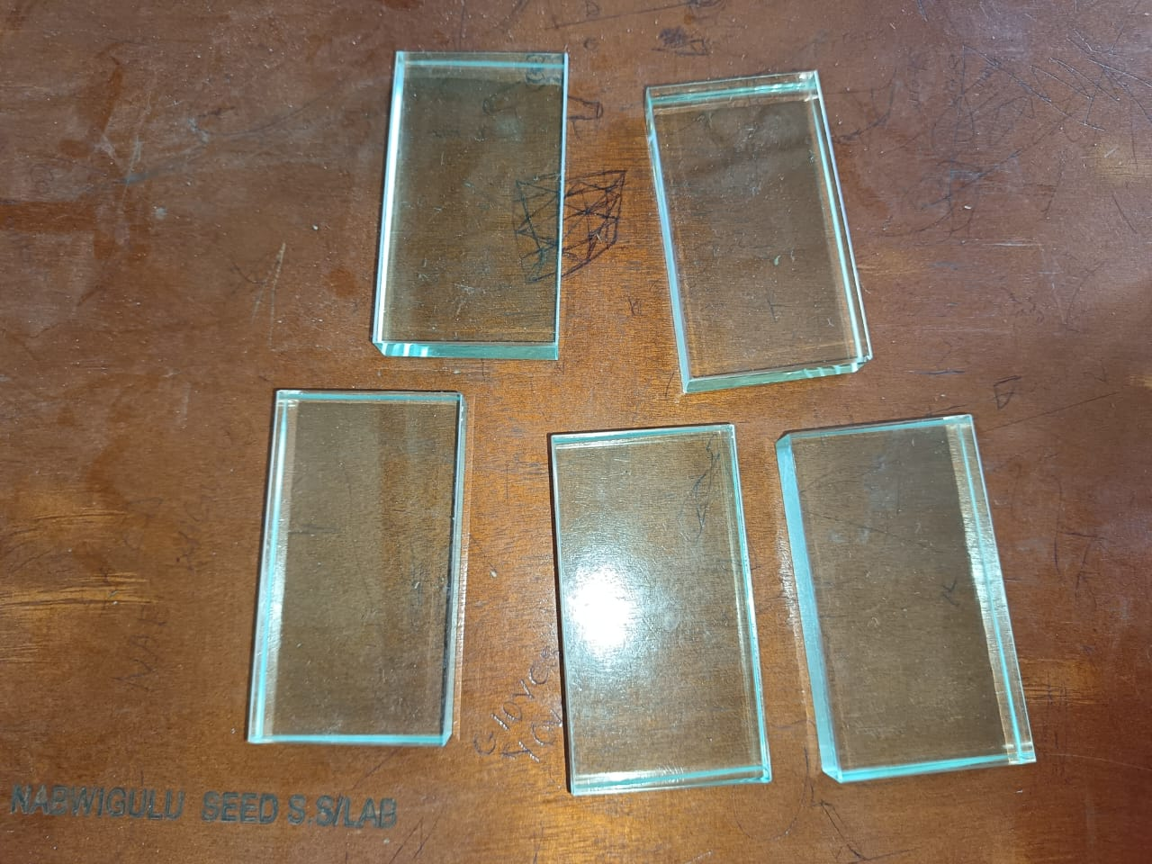
GLASS BLOCKS
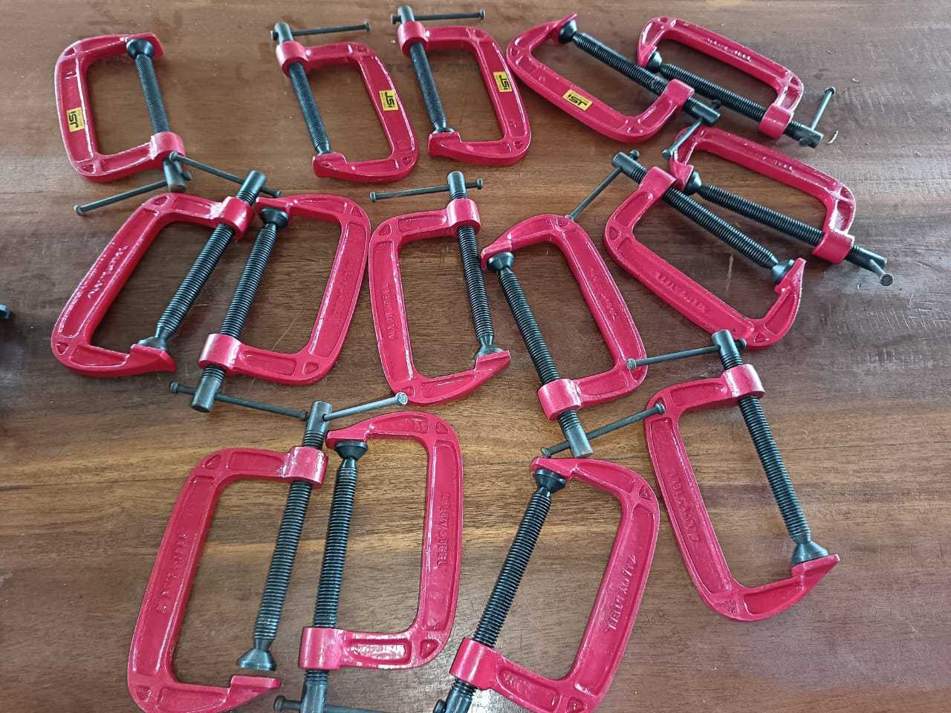
G- CLAMPS
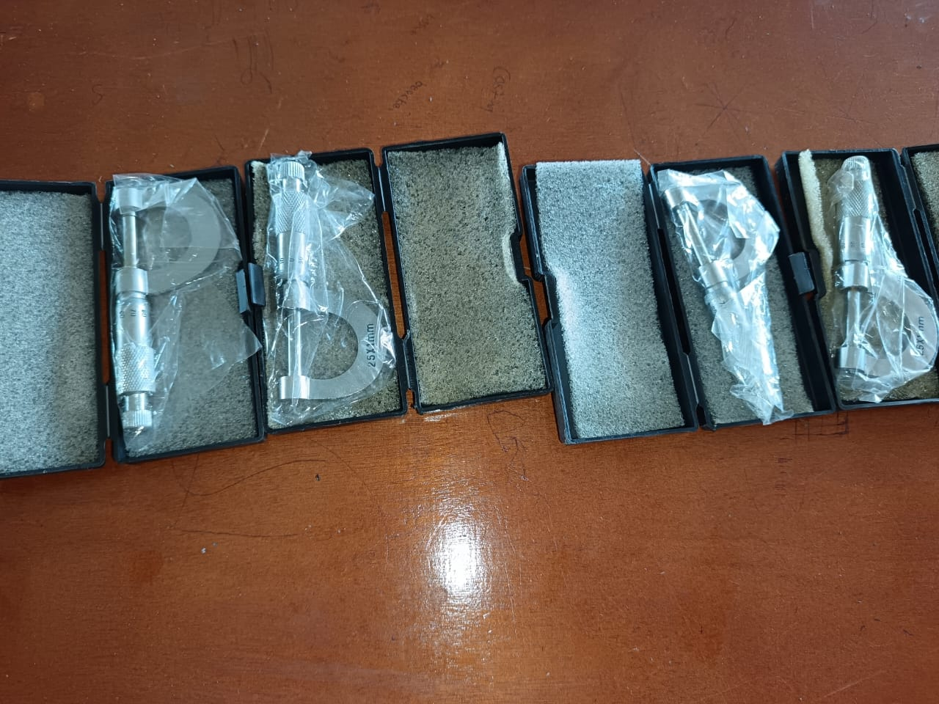
MICROMETER SCREW GAUGE
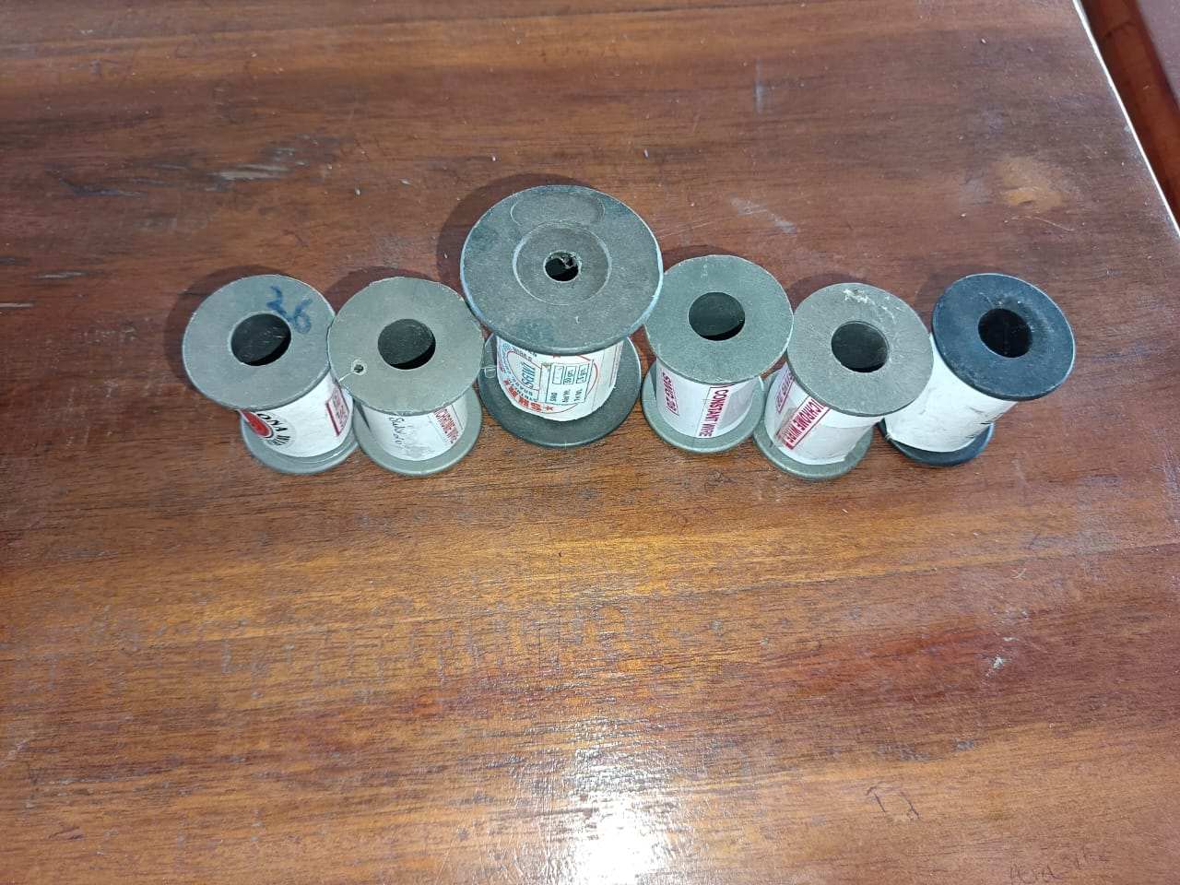
BARE WIRES
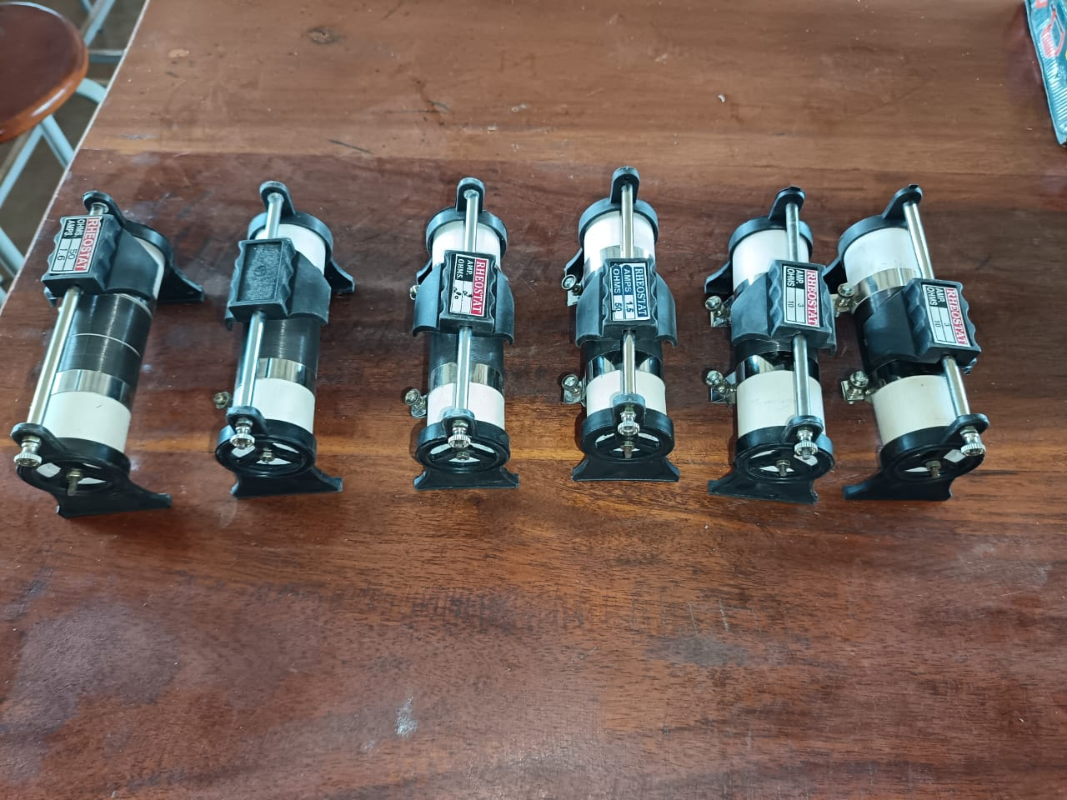
VARIABLE RESISTORS (RHEOSTARTS)
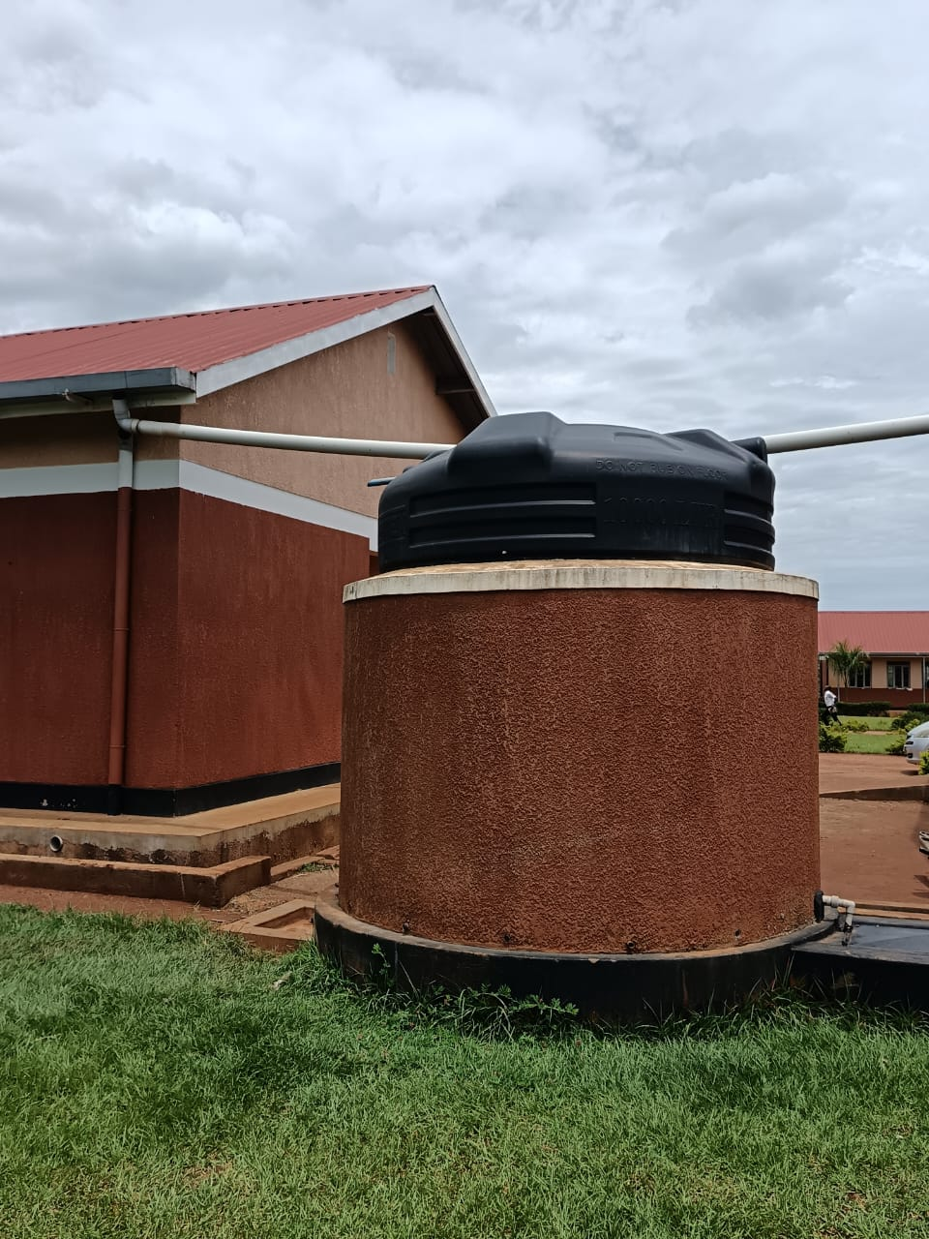
LABORATORY WATER TANK
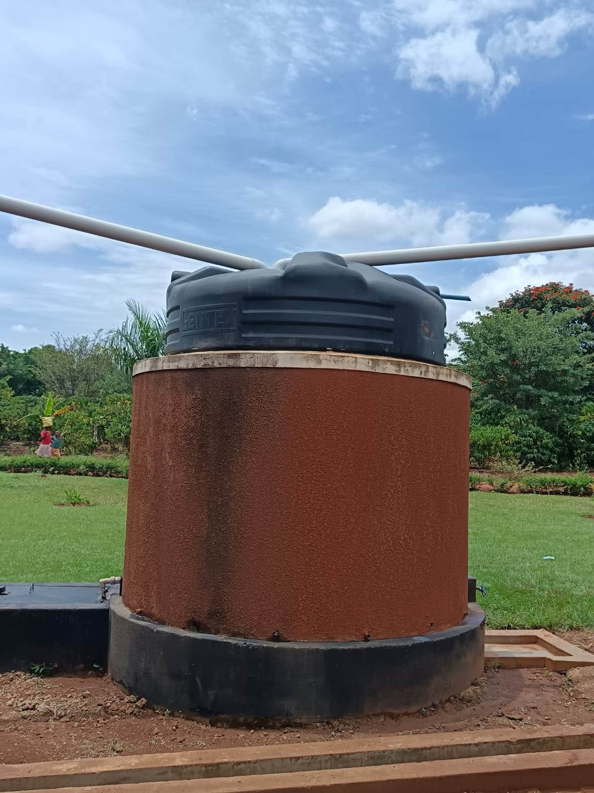
LABORATORY WATER TANK
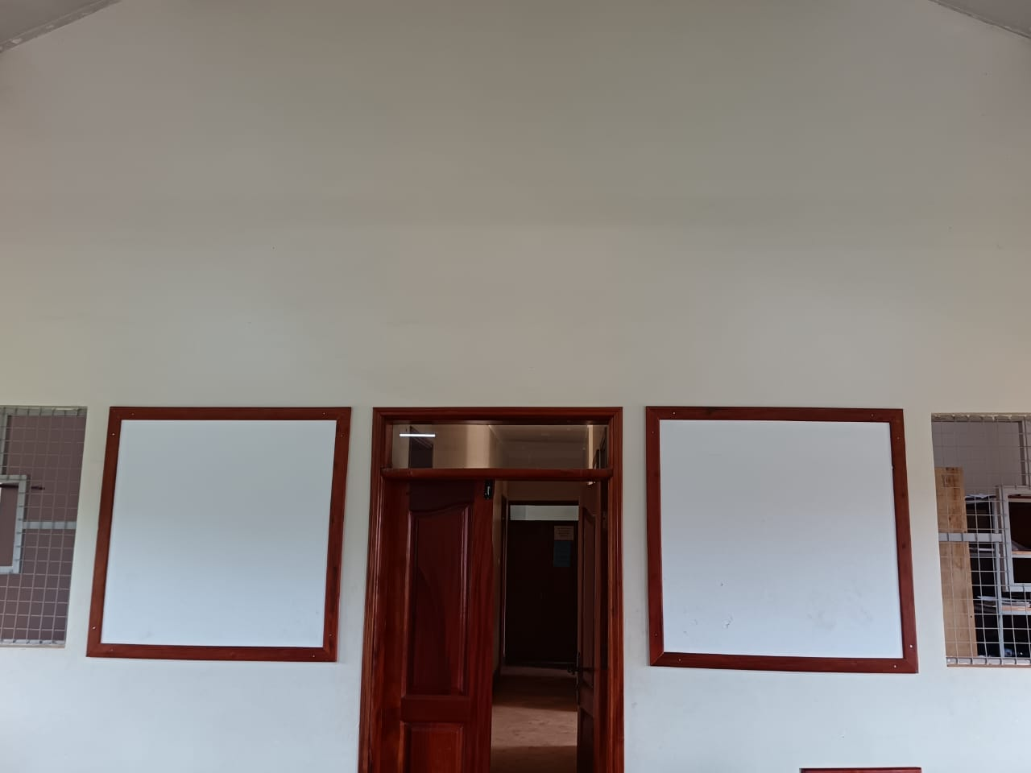
NOTICE BORDS IN THE ICT ROOM
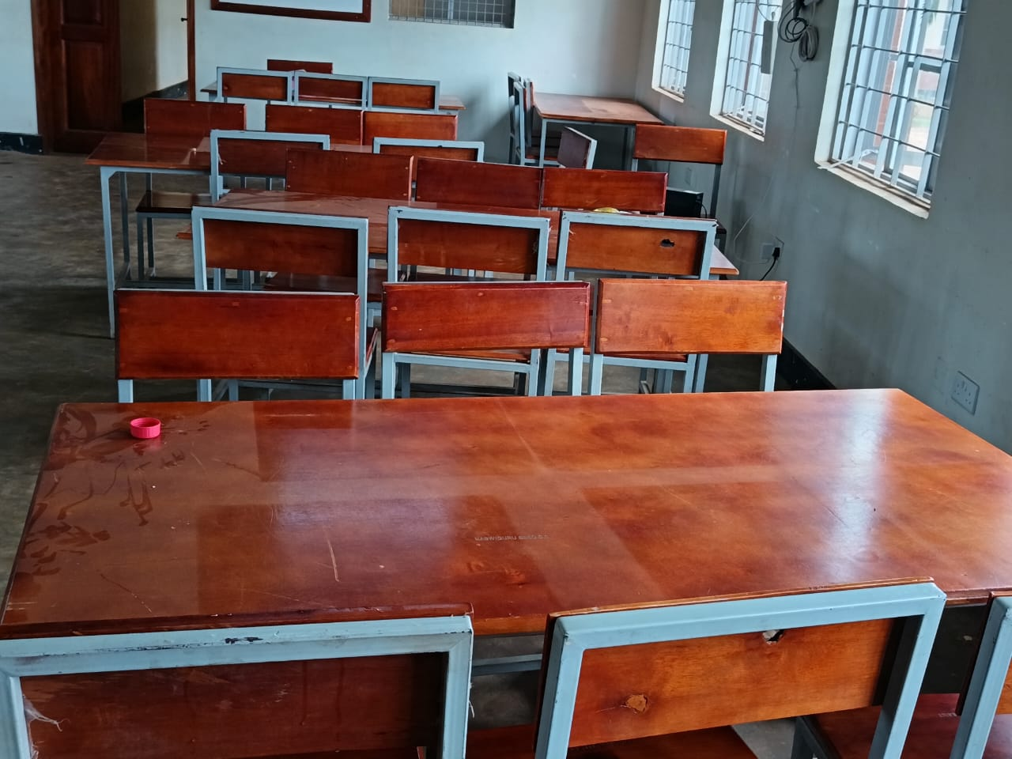
CHAIRS AND TABLES IN ICT ROOM
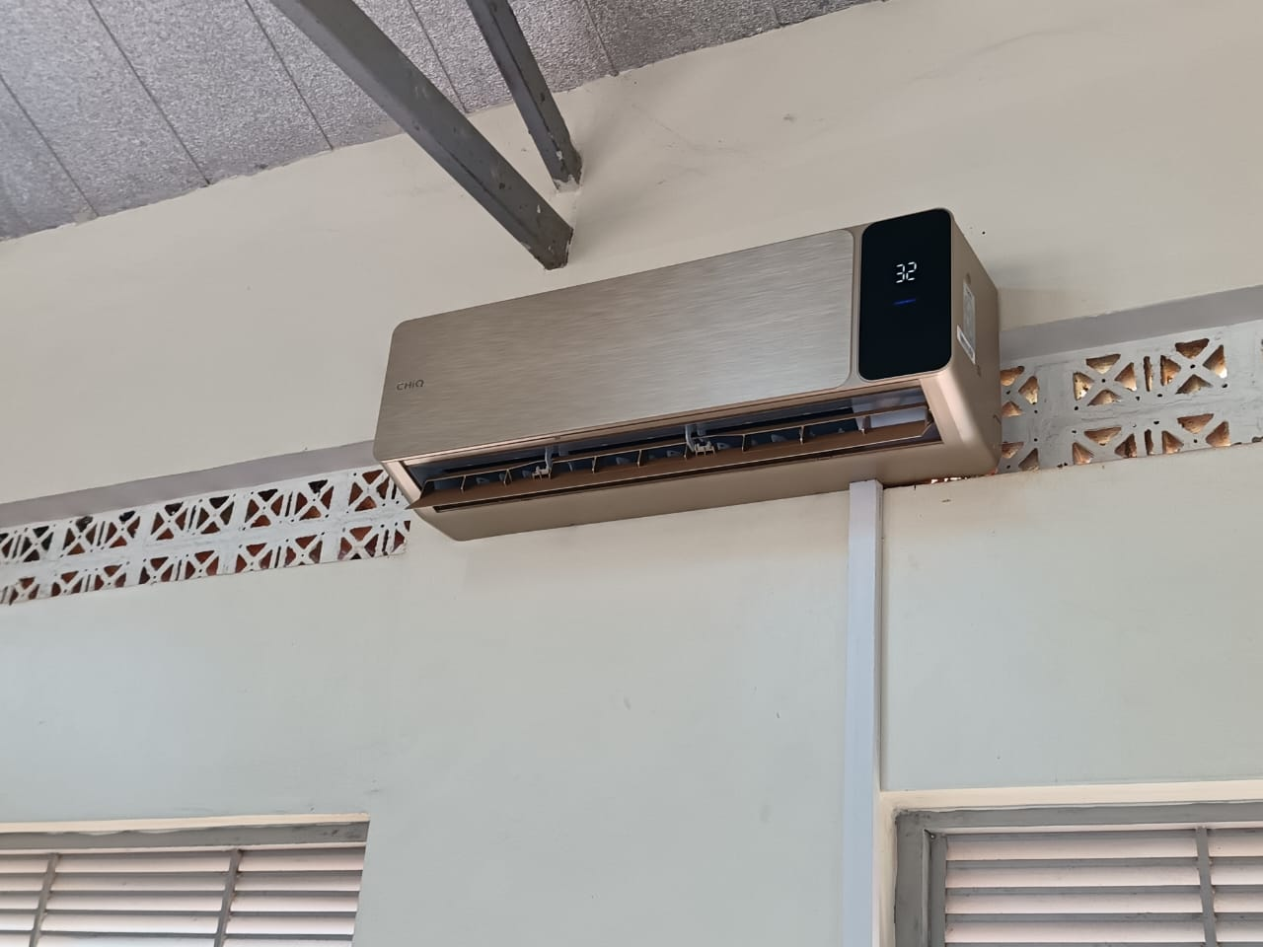
AIR CONDITIONER: INDOOR UNIT
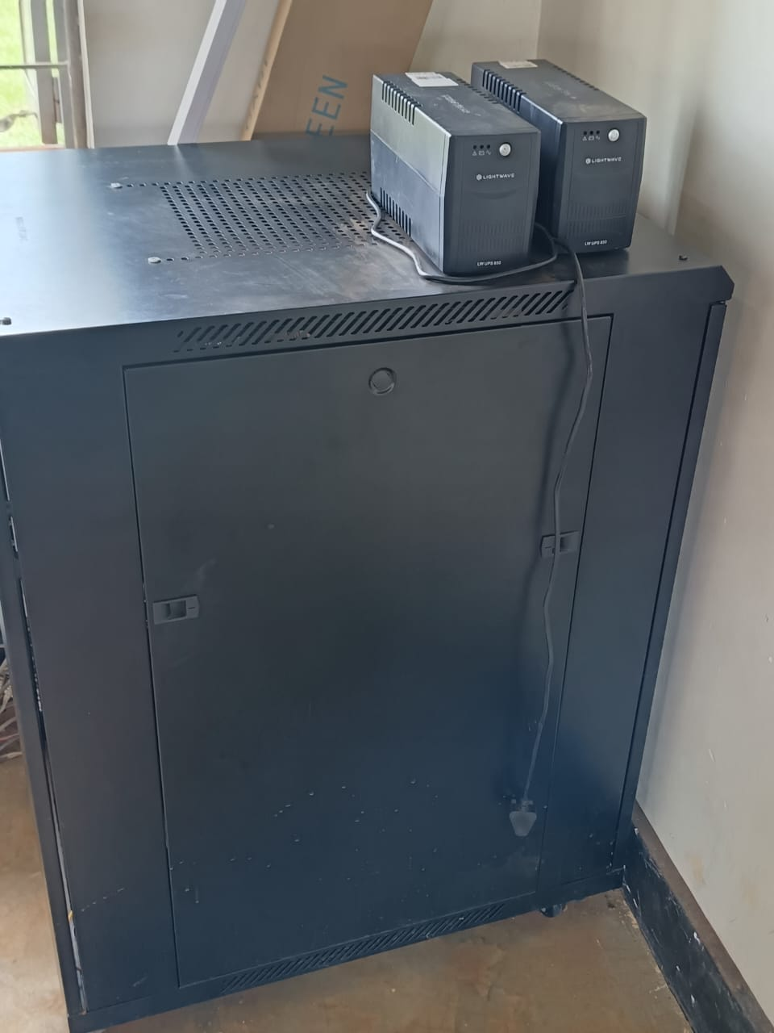
DATA CABINET WHERE IS A HARDWARE FIREWALL, SAVER, NETWORK SWITCH AND PATCH PANEL
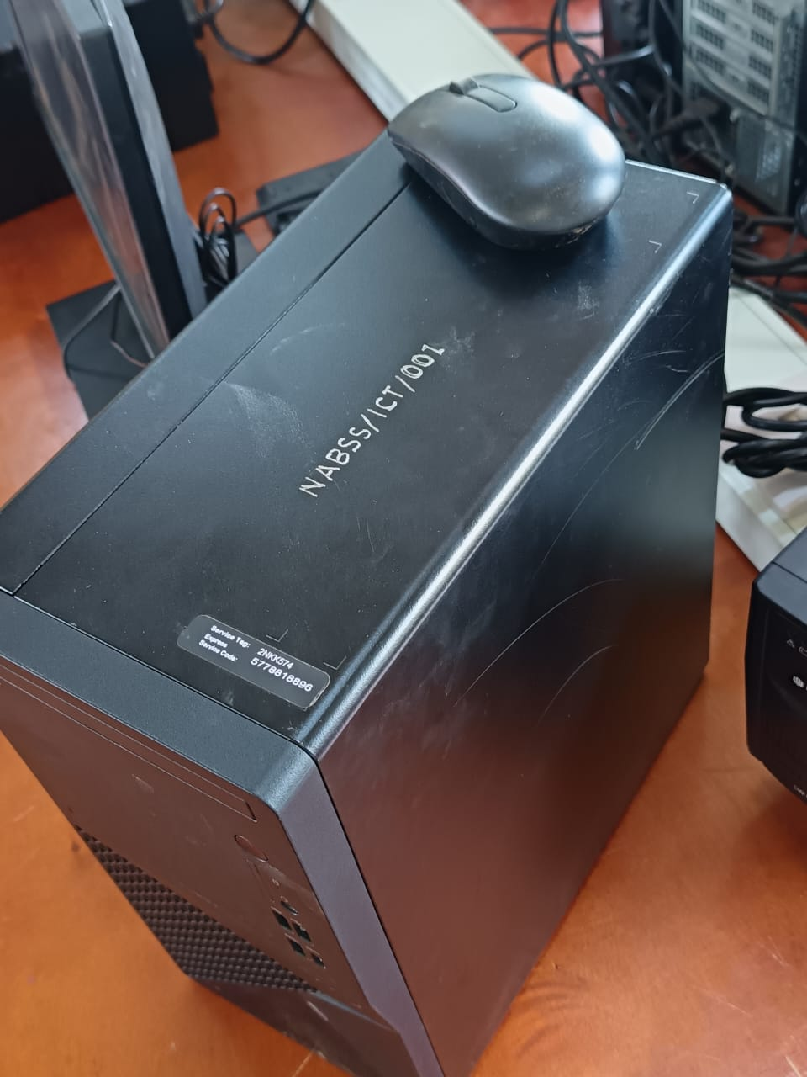
COMPUTER IN ICT ROOM
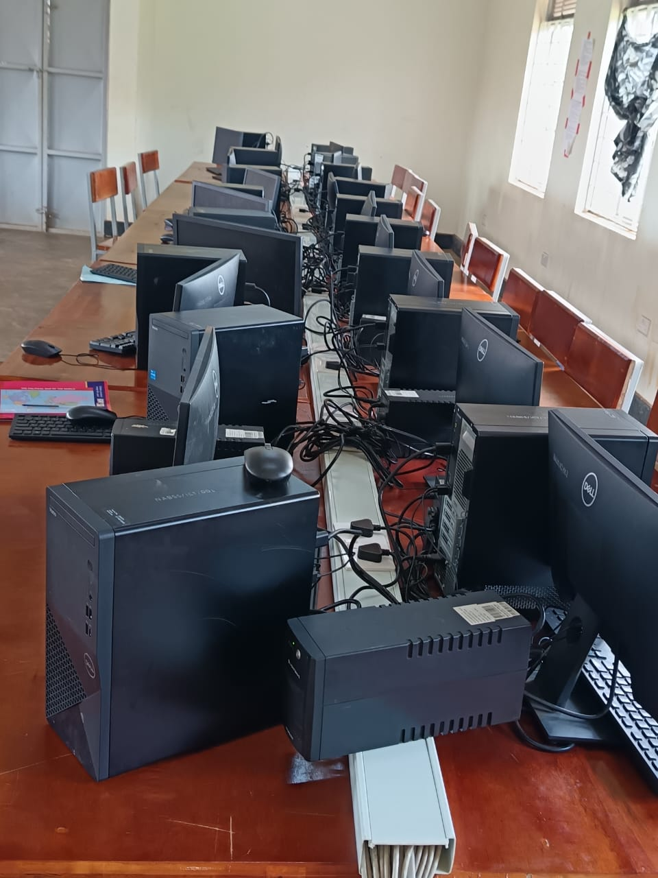
ICT LABORATORY
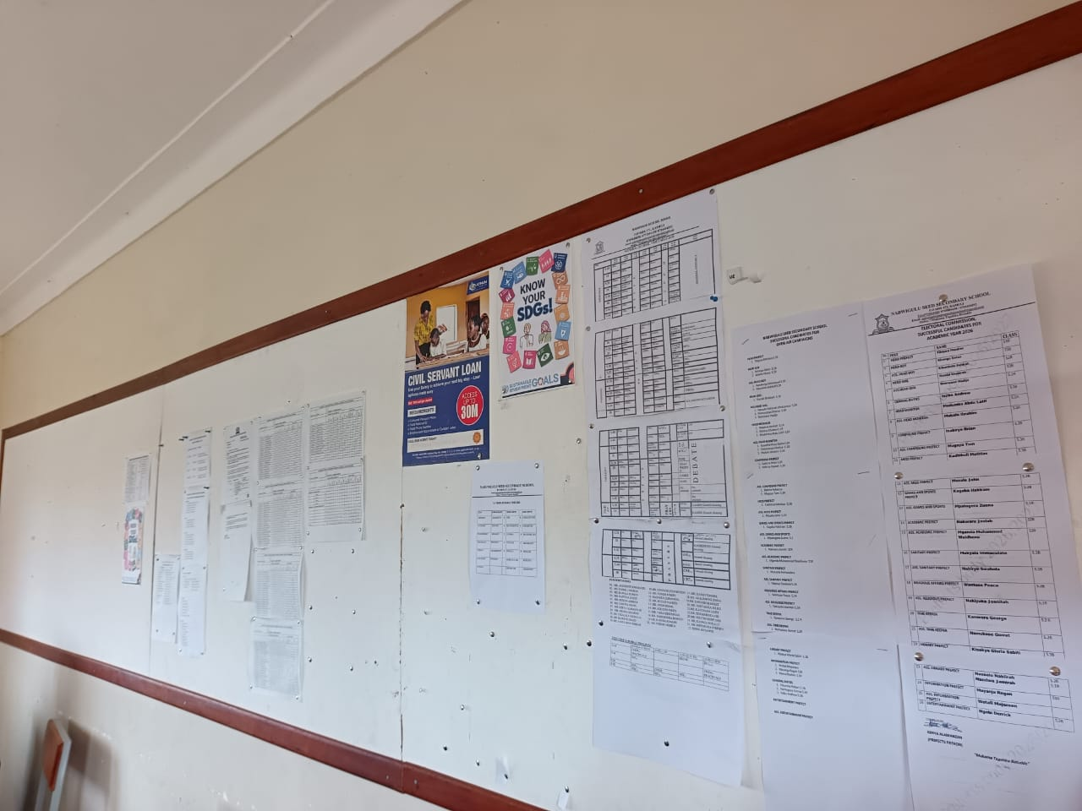
STAFF ROOM NOTICE BOARD
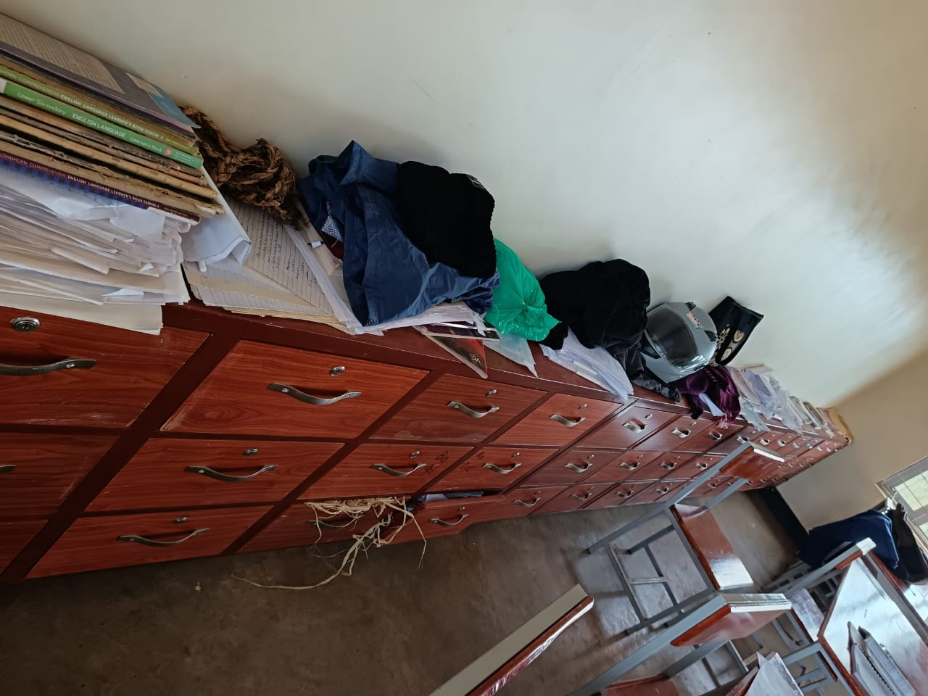
TEACHERS’ LOCKERS IN THE STAFF ROOM
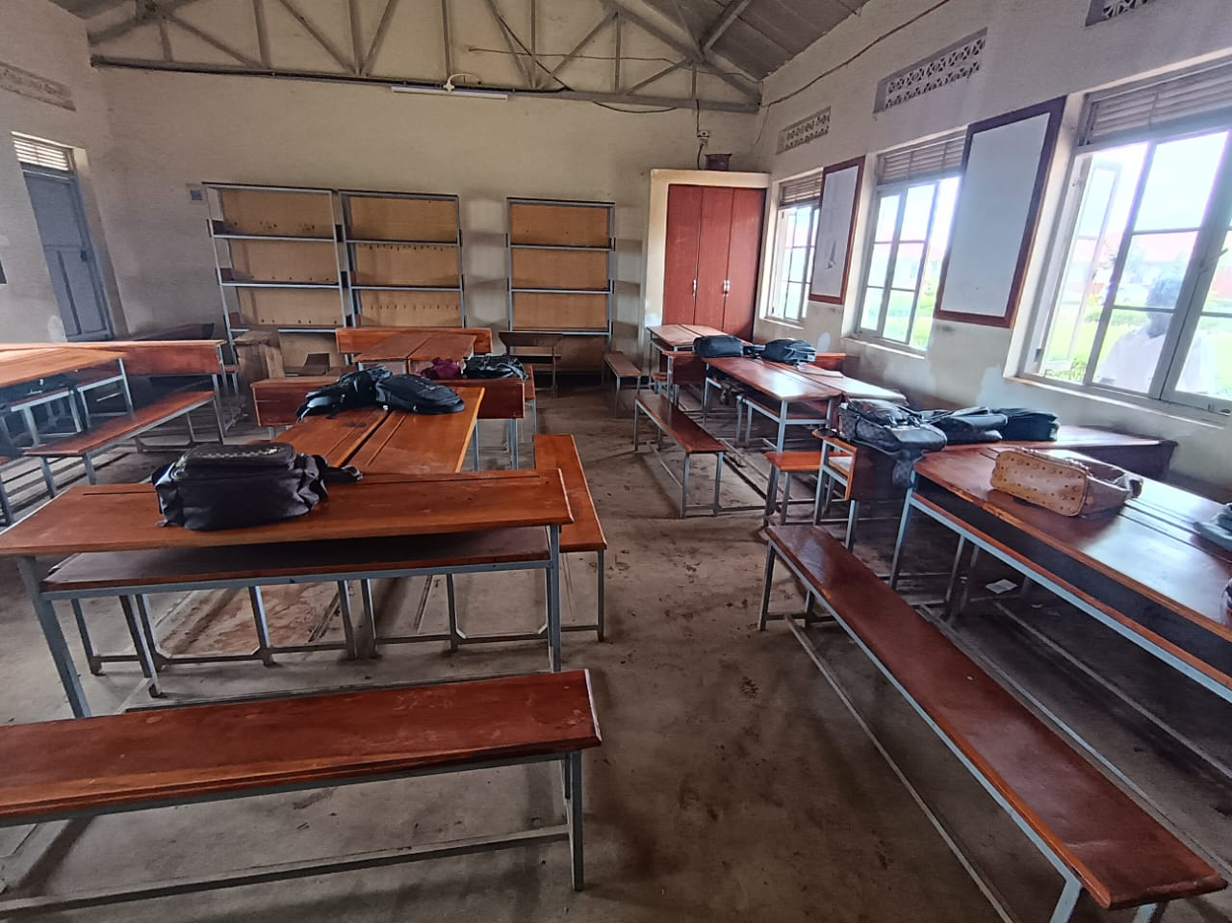
CLASS ROOM
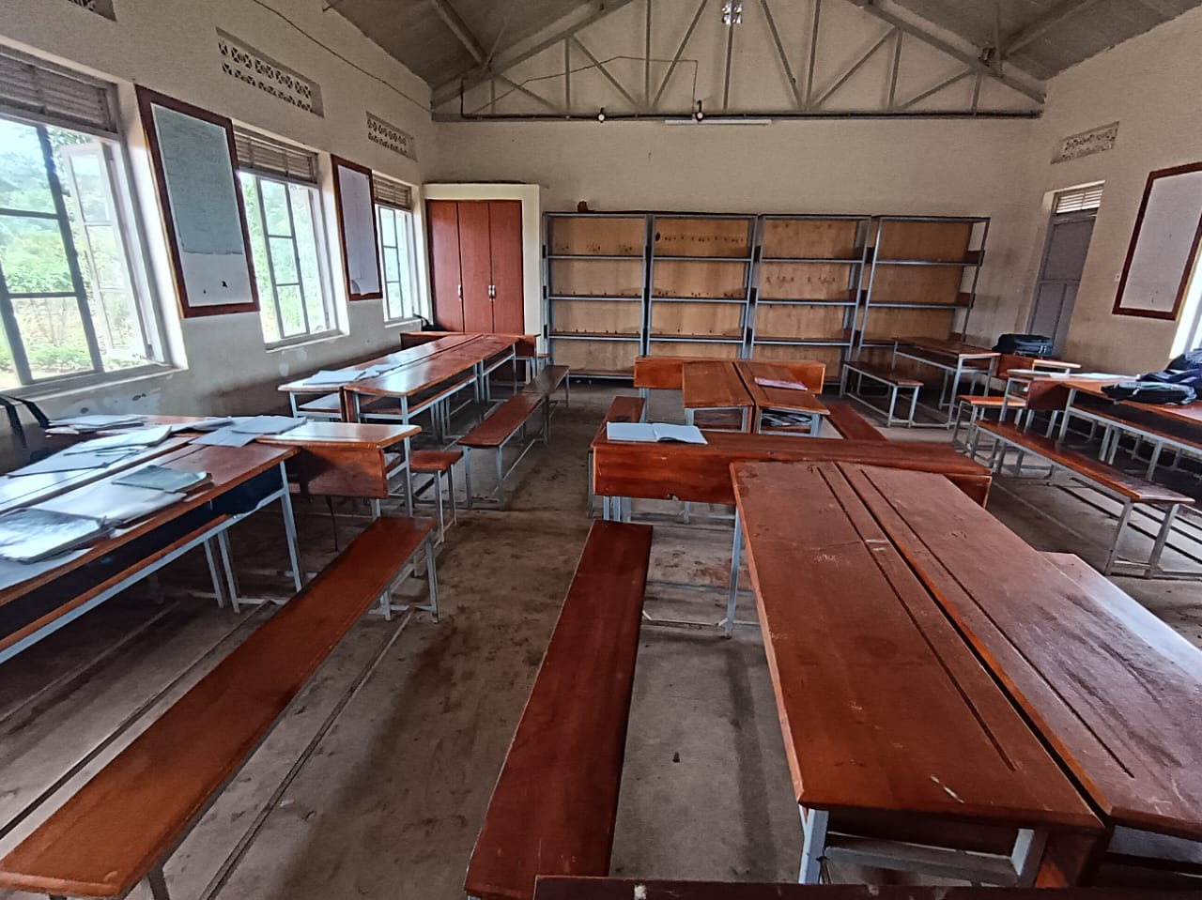
CLASS ROOM ENVIRONMENT
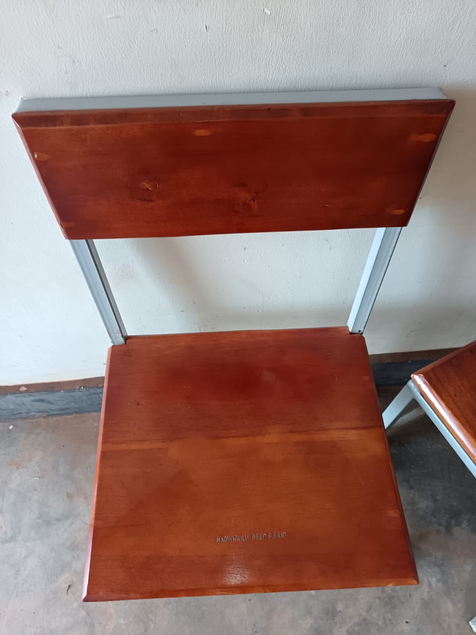
OFFICE CHAIR
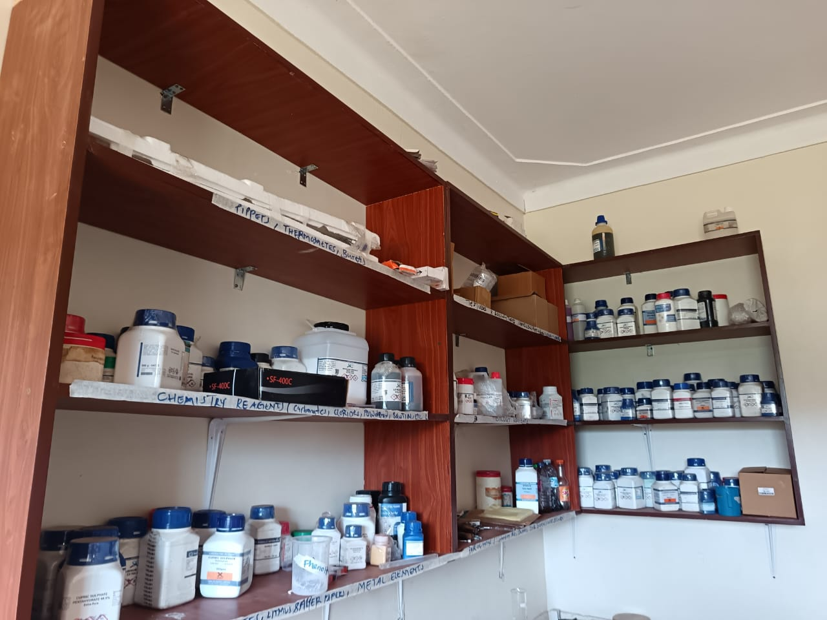
CHEMICALS IN STORAGE
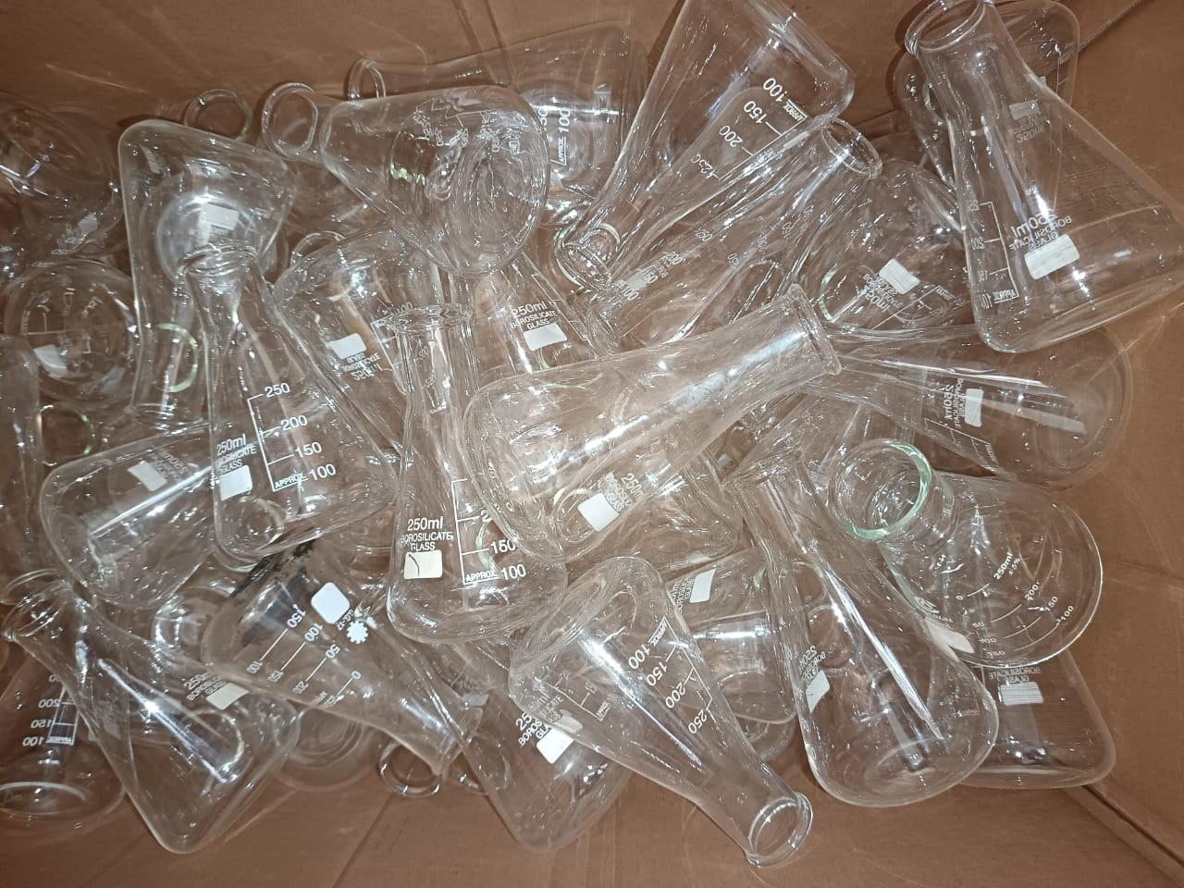
CONICAL FLASKS
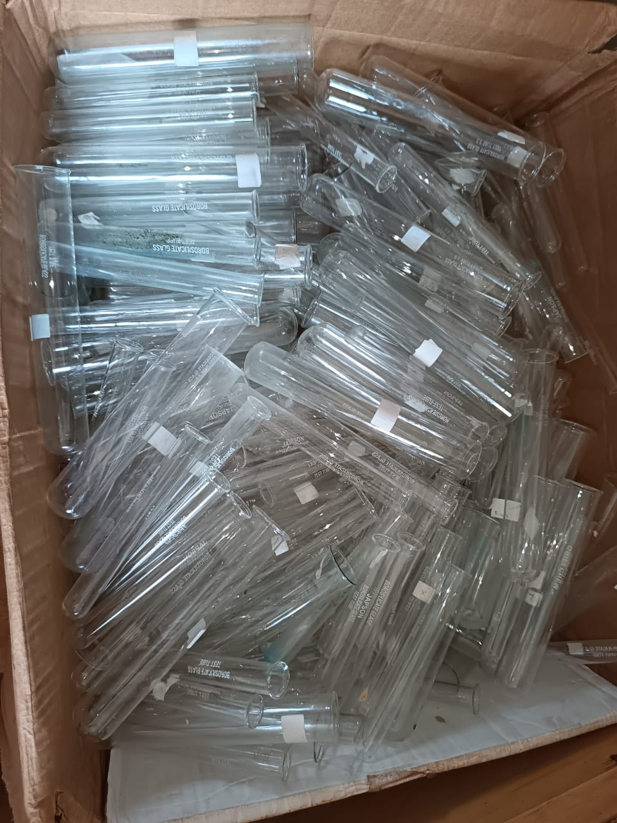
TEST TUBES
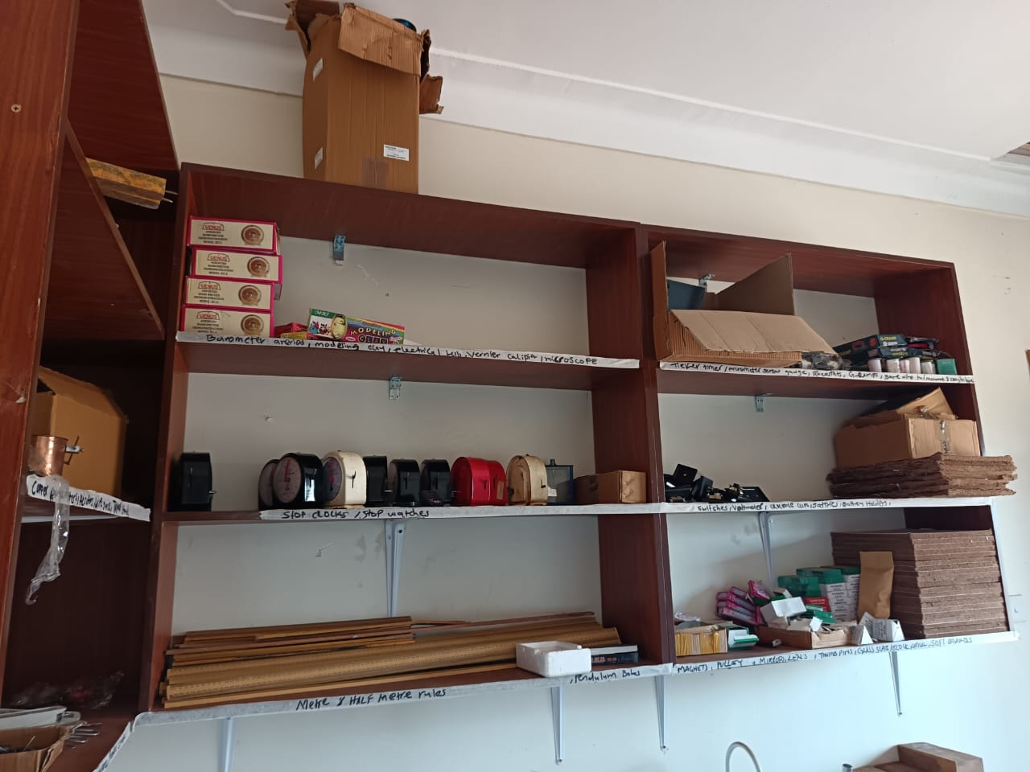
PHYSICS APPARATUSES
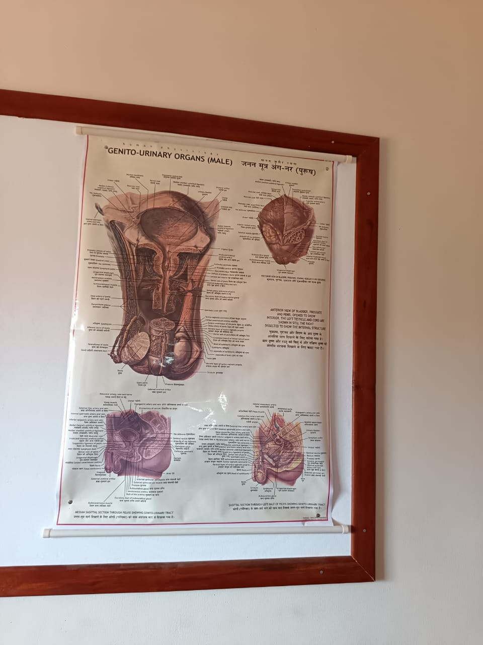
BIOLOGY CHART
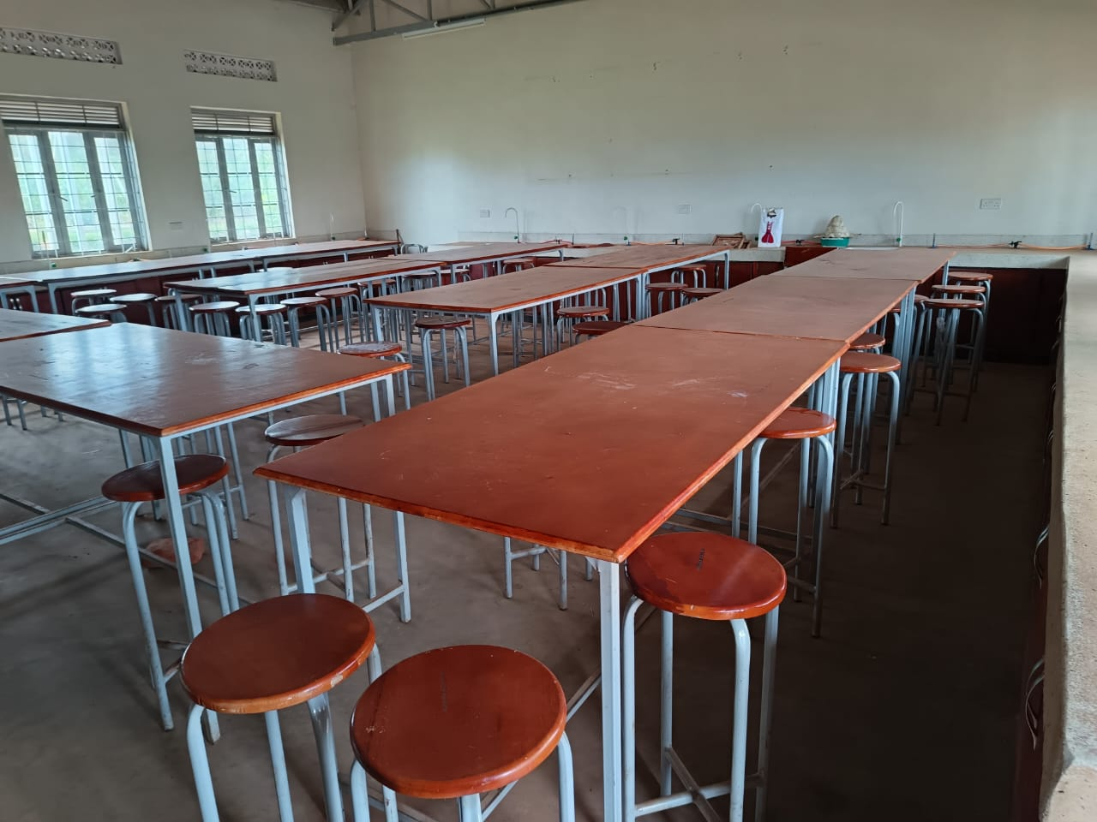
SCIENCE LABORATORY
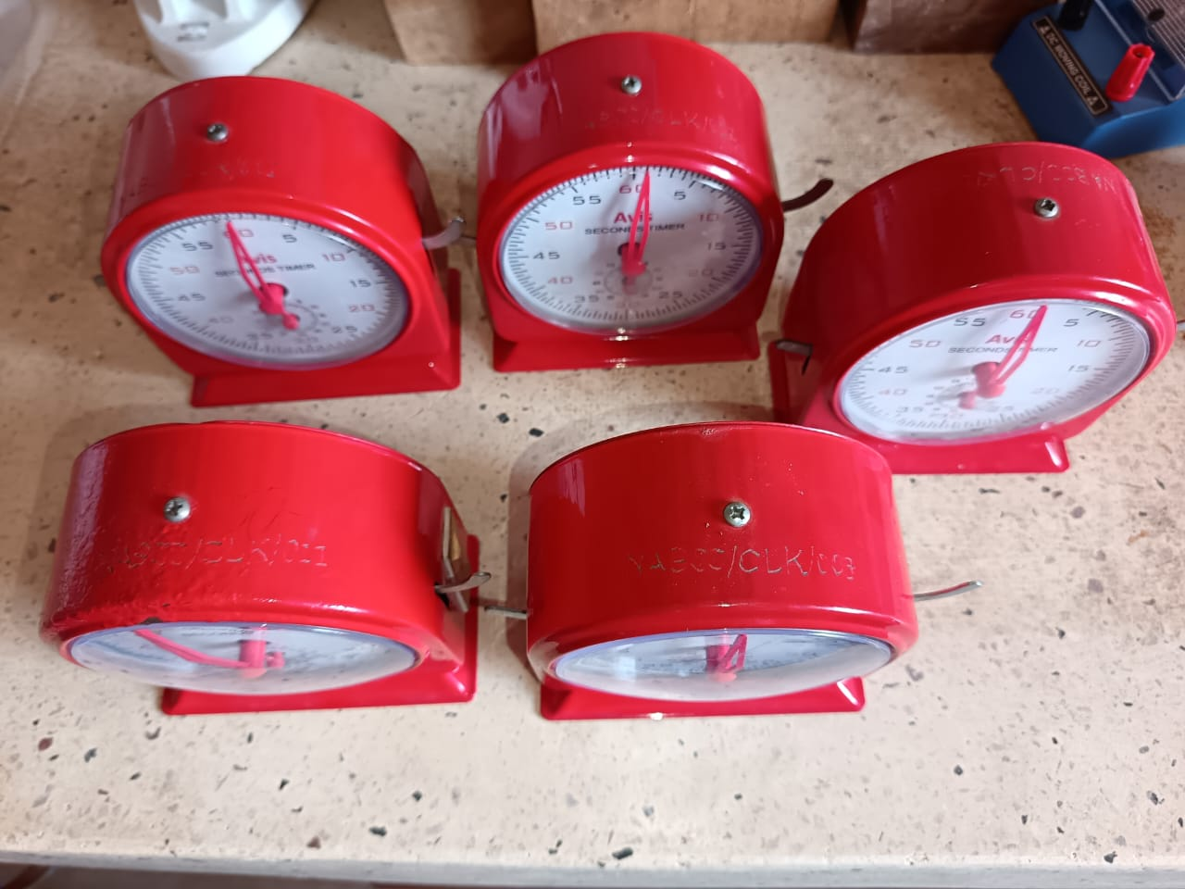
STOP CLOCKS
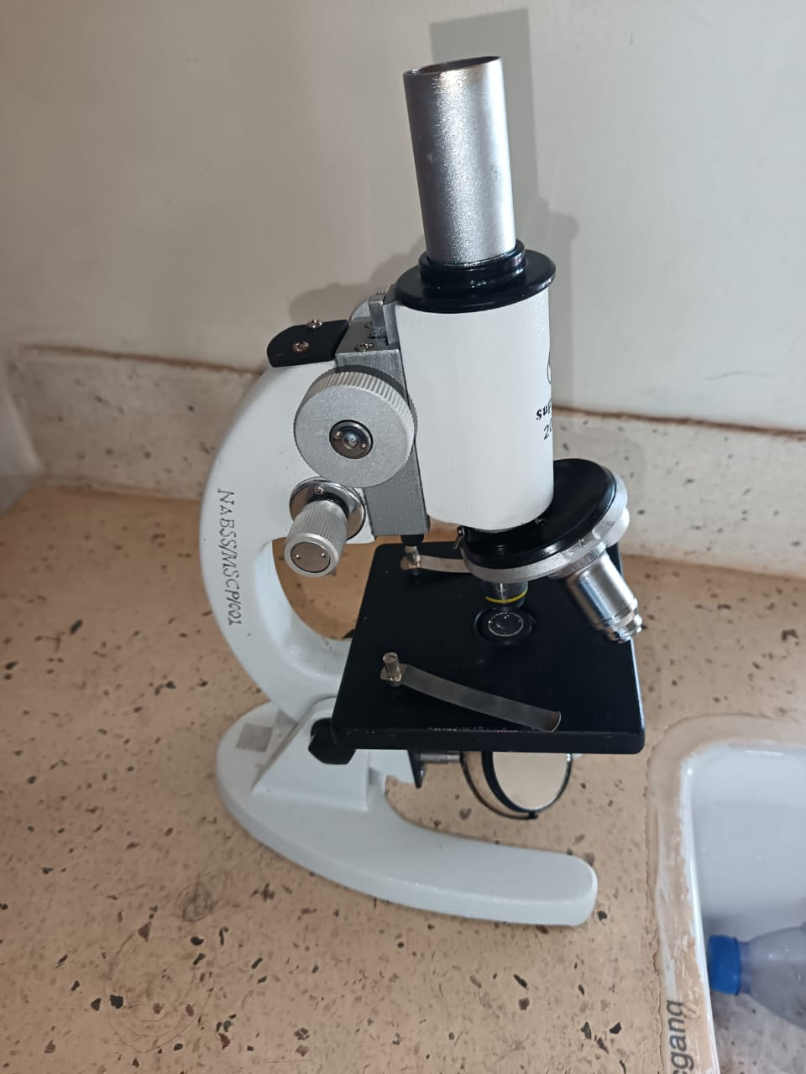
MICROSCOPE
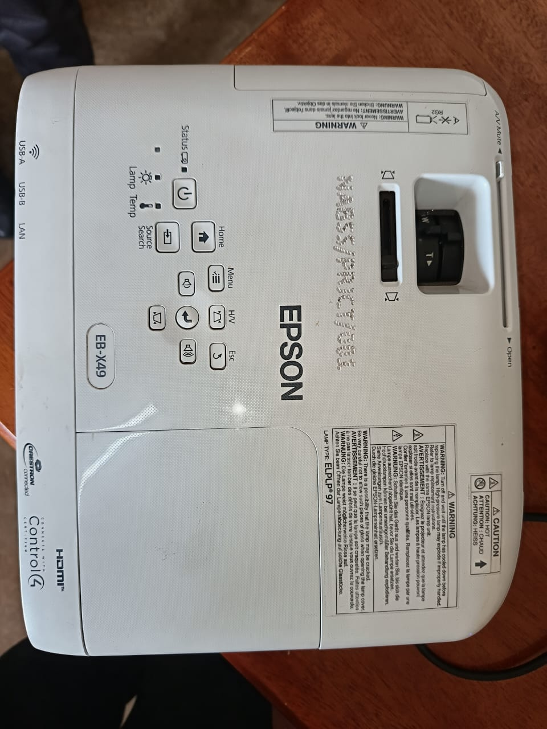
PROJECTOR

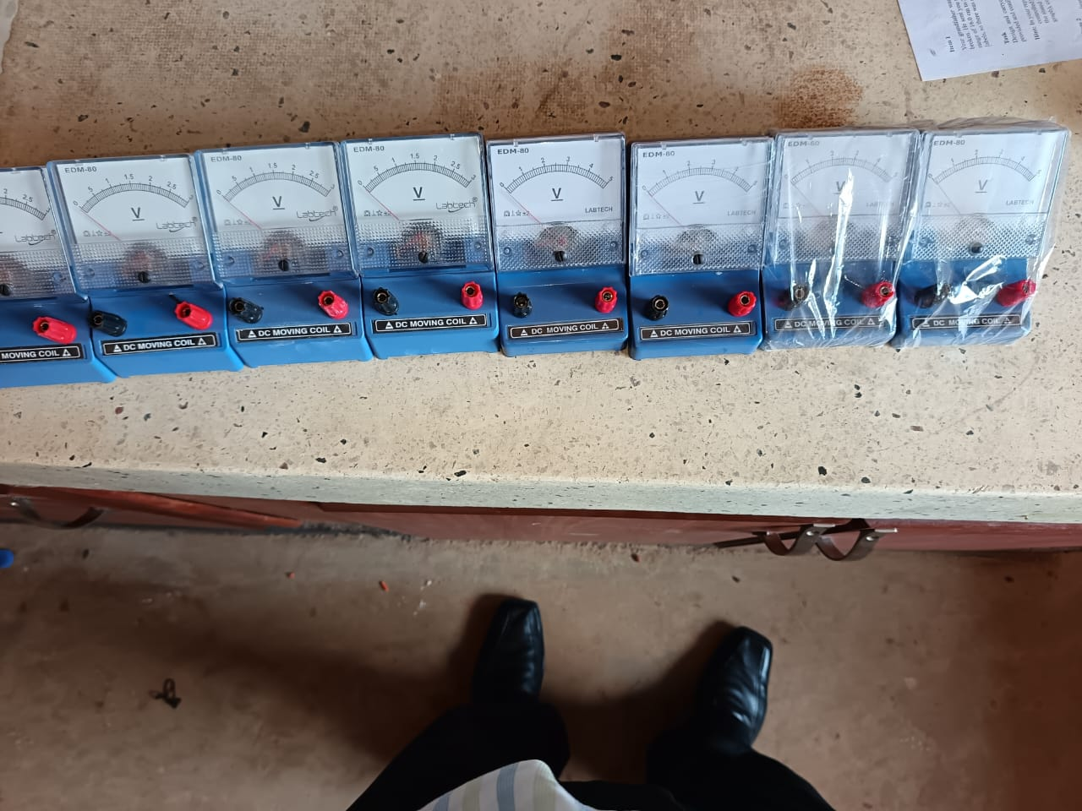
VOLTIMETERS
WOODEN BLOCKS
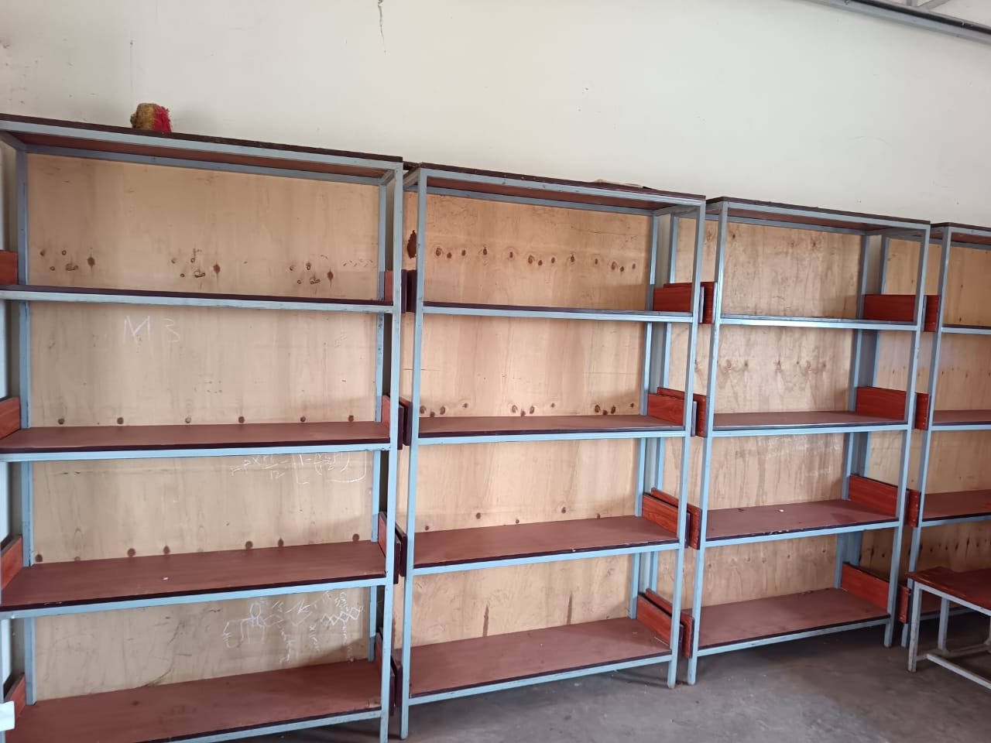
CLASS ROOM SHEELVES
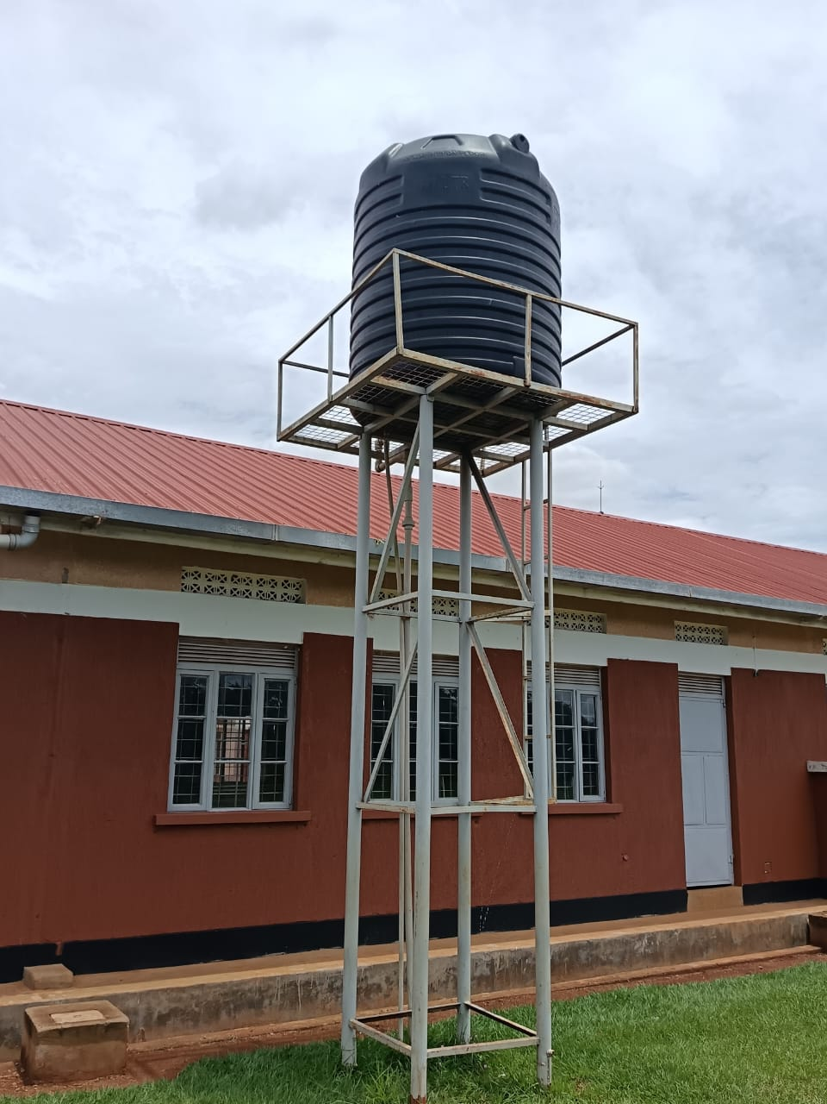
SCIENCE LABORATORY WATER TANK
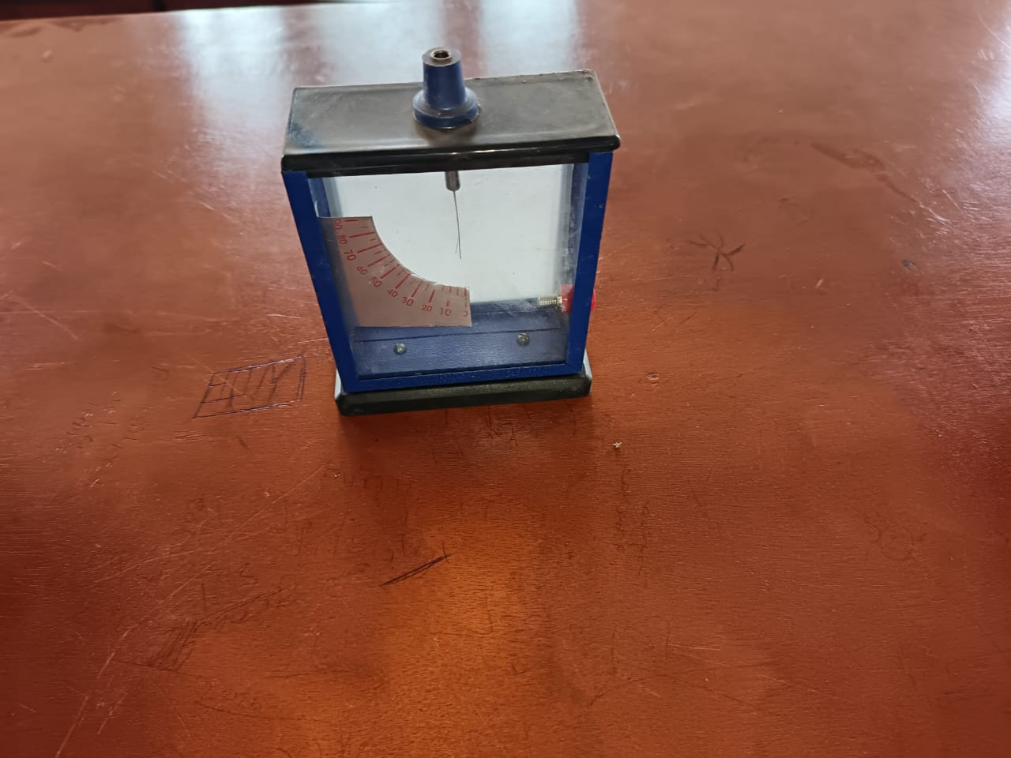
GOLD LEAF ELECTROSCOPE

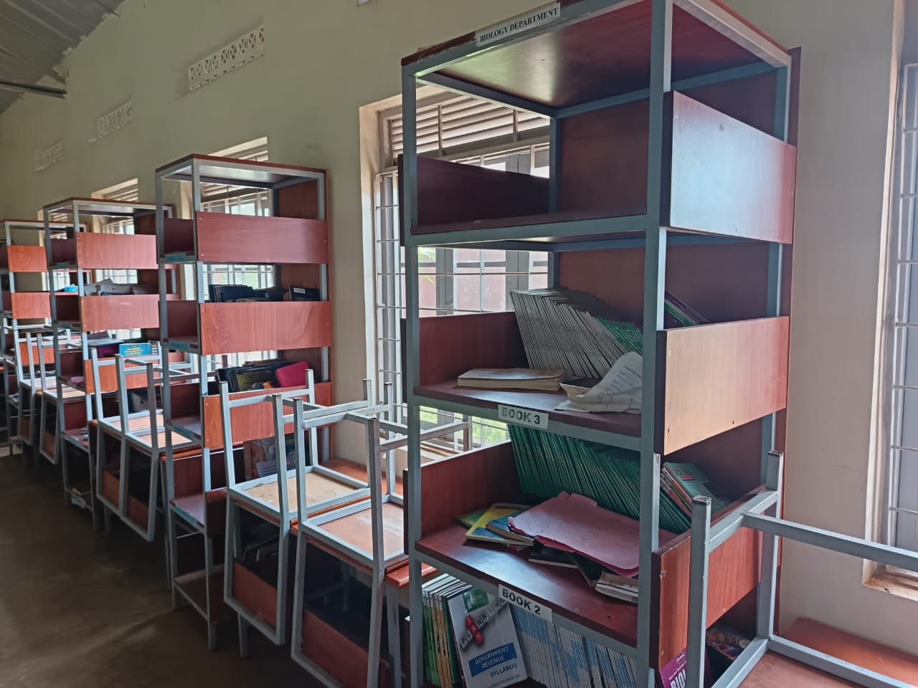
LIBRARY SHELVES
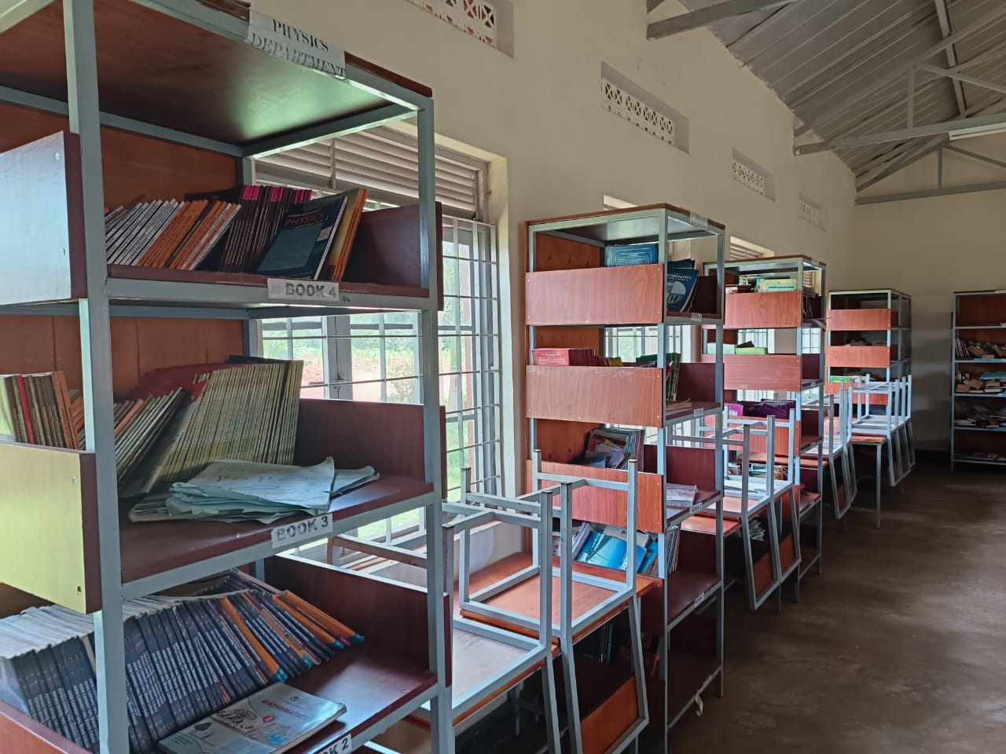
LIBRARY SHELVES

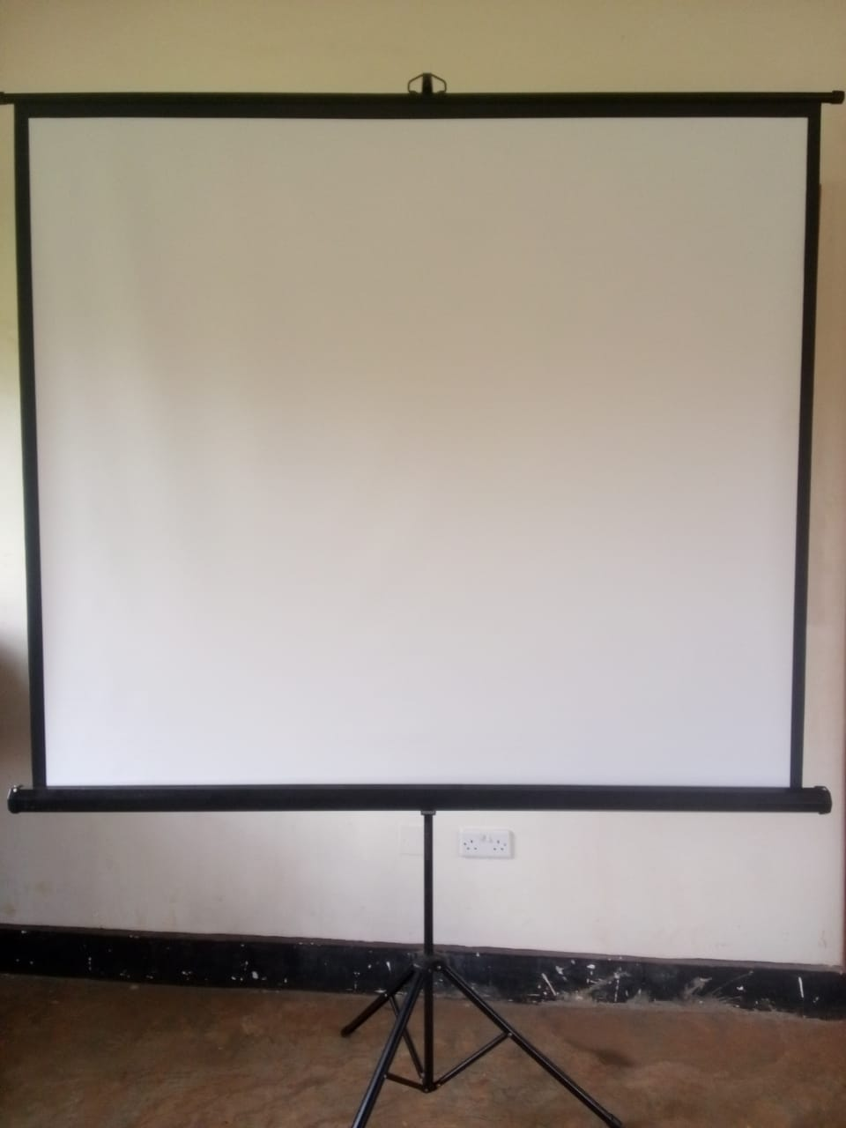
PROJECTOR SCREEN ON A STAND
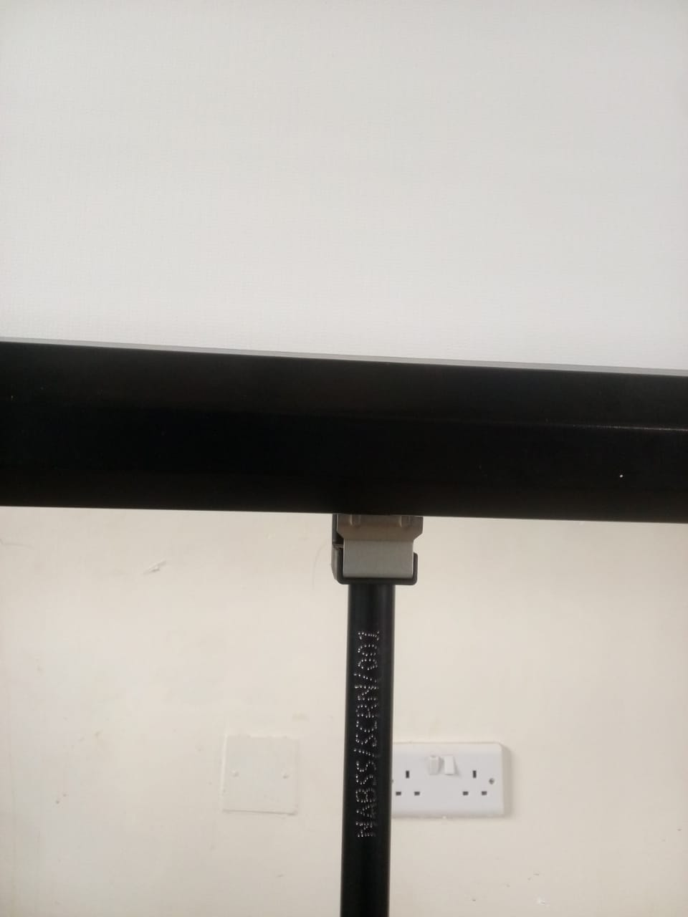

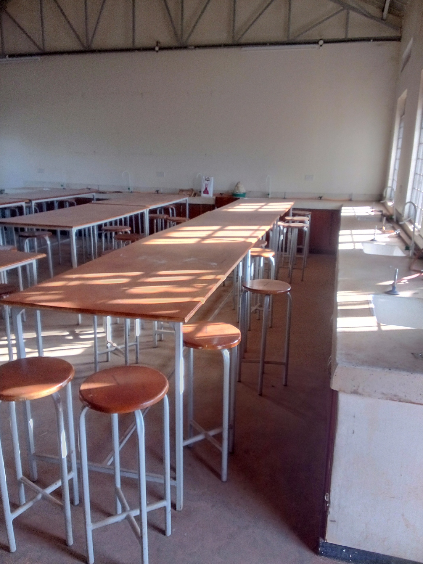
LABORATORY ROOM2

